**Year 1 Holiday Homework**

**D & T – Make your own wheeled toy at home!**

Our D&T unit this term is ‘Wheels and Axles.’

In lessons, we have explored fixing wheels and axles together onto a chassis so that the wheels can turn.

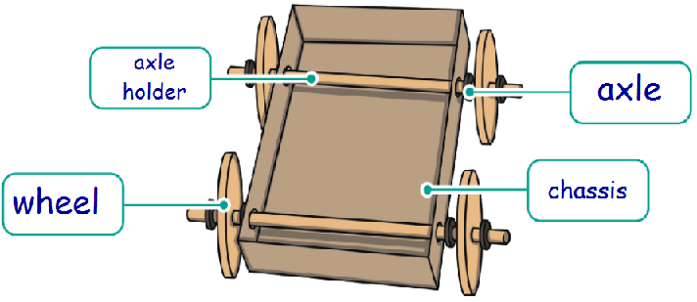

Axles can be fixed onto the chassis so that they do not turn:

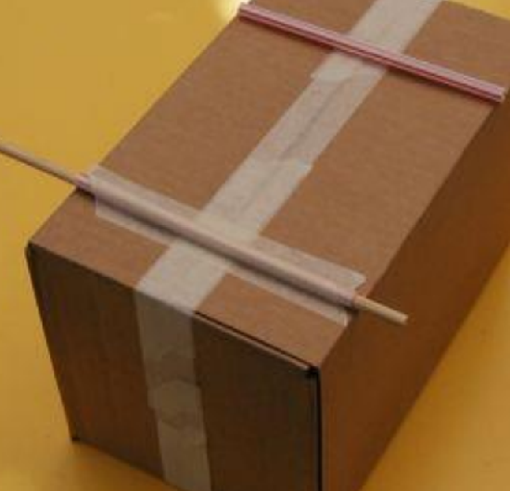 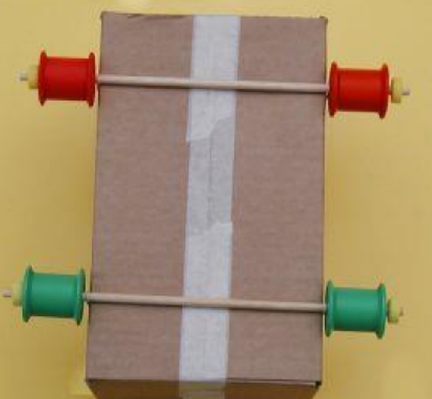 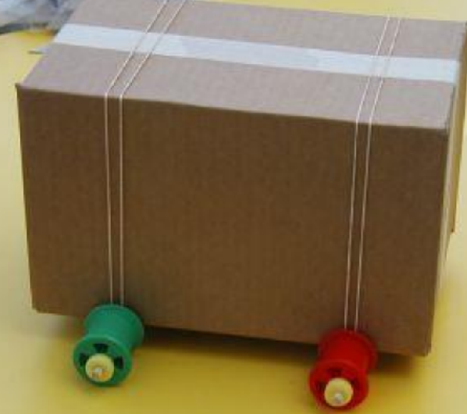

**OR,** axles can be put inside an axle holder which allows them to turn:

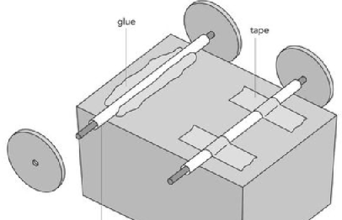

In school, we looked at how a simple wheeled toy car could be made:

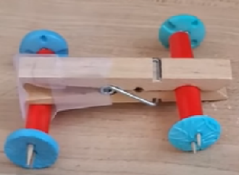 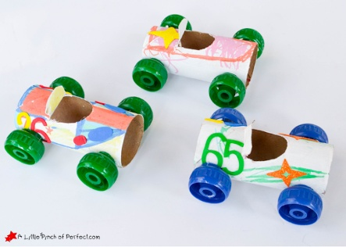

**OR,** you might have your own ideas. I can’t wait to see them after the holidays!

If you would like to find out more, I have put some useful documents and links on our school Year 1 website page under the ‘D&T’ tab.. Please take a look!