Spring One, week 4: 27/01/2025 Y6 Spellings: Y3/4 words Ms. Lennox-Douglas

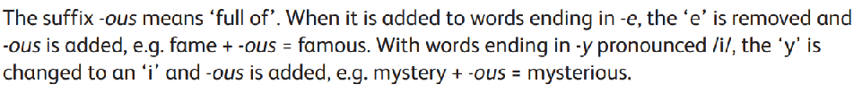

1. fame
2. famous
3. adventure
4. adventurous
5. joy
6. joyous
7. ridicule
8. ridiculous
9. fury
10. furious
11. prosper
12. prosperous
13. poison
14. poisonous
15. mountain
16. mountainous
17. hazard
18. hazardous
19. nerve
20. nervous
21. space
22. spacious
23. mystery
24. mysterious