|  |  |
| --- | --- |
| **Key vocabulary** | |
| **vertebrate** | Animals that have a backbone. They can be divided into 5 groups: fish, amphibians, reptiles, birds and mammals. |
| **invertebrate** | Animals that do not have a backbone. Can be divided into several groups including insects, spiders, snails and worms. |
| **arachnid** | An animal that has eight legs and a body formed of two parts |
| **crustacean** | Animals which mostly live in water with a hard shell and segmented body |
| **microorganism** | A microscopic organism, especially a bacteria, virus or fungus |

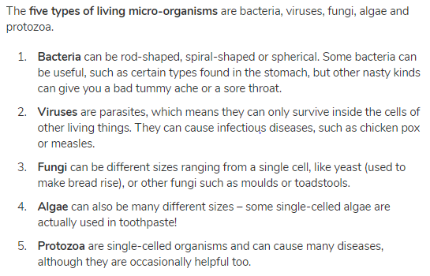

**Classification**

Living things can be classified into broad groups according to observable characteristics that are similar or different.

**Living things and their habitats – Year 6**

|  |  |
| --- | --- |
| **Significant scientists** | |
| **Carl Linnaeus**  *(1707-1778)* | Carl Linnaeus was a Swedish scientist who developed the modern system of classifying and naming organisms. Before this the names of living things were often very long. He gave them a two-part name. |
| **Chris Nelson** | Chris Nelson is a horticulturist and a director of Growing Underground which uses hydroponic techniques to grow pesticide-free crops in a former London underground air-raid shelter. |

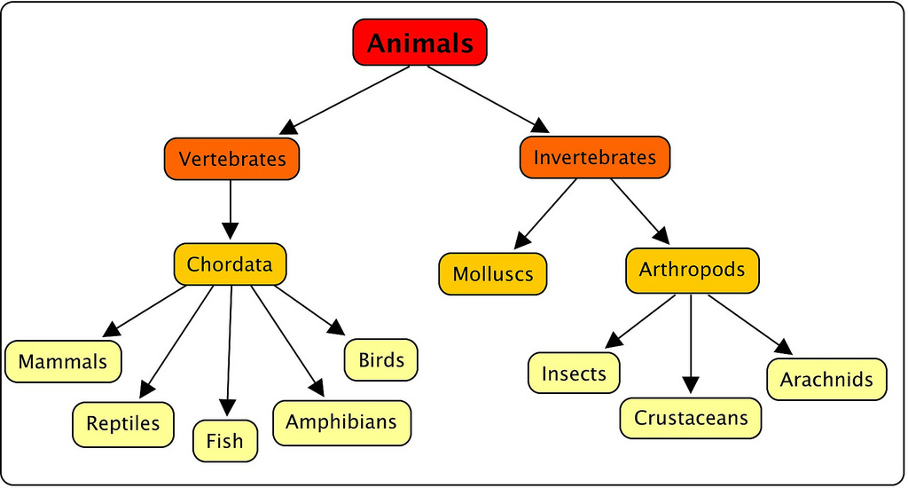

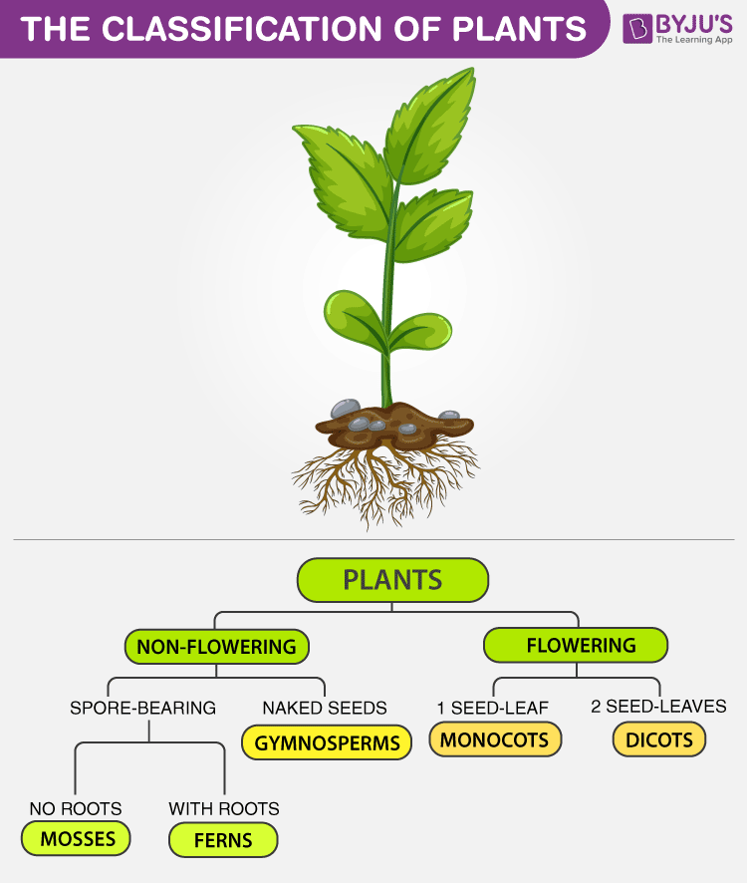

**Flowering plants –** numerous and diverse group. Reproduce through flowers and seeds. E.g. sunflower

**Non-flowering plants** – smaller group. They have a simple structure and do not have flowers or seeds. They reproduce through spores. E.g. algae, mosses

