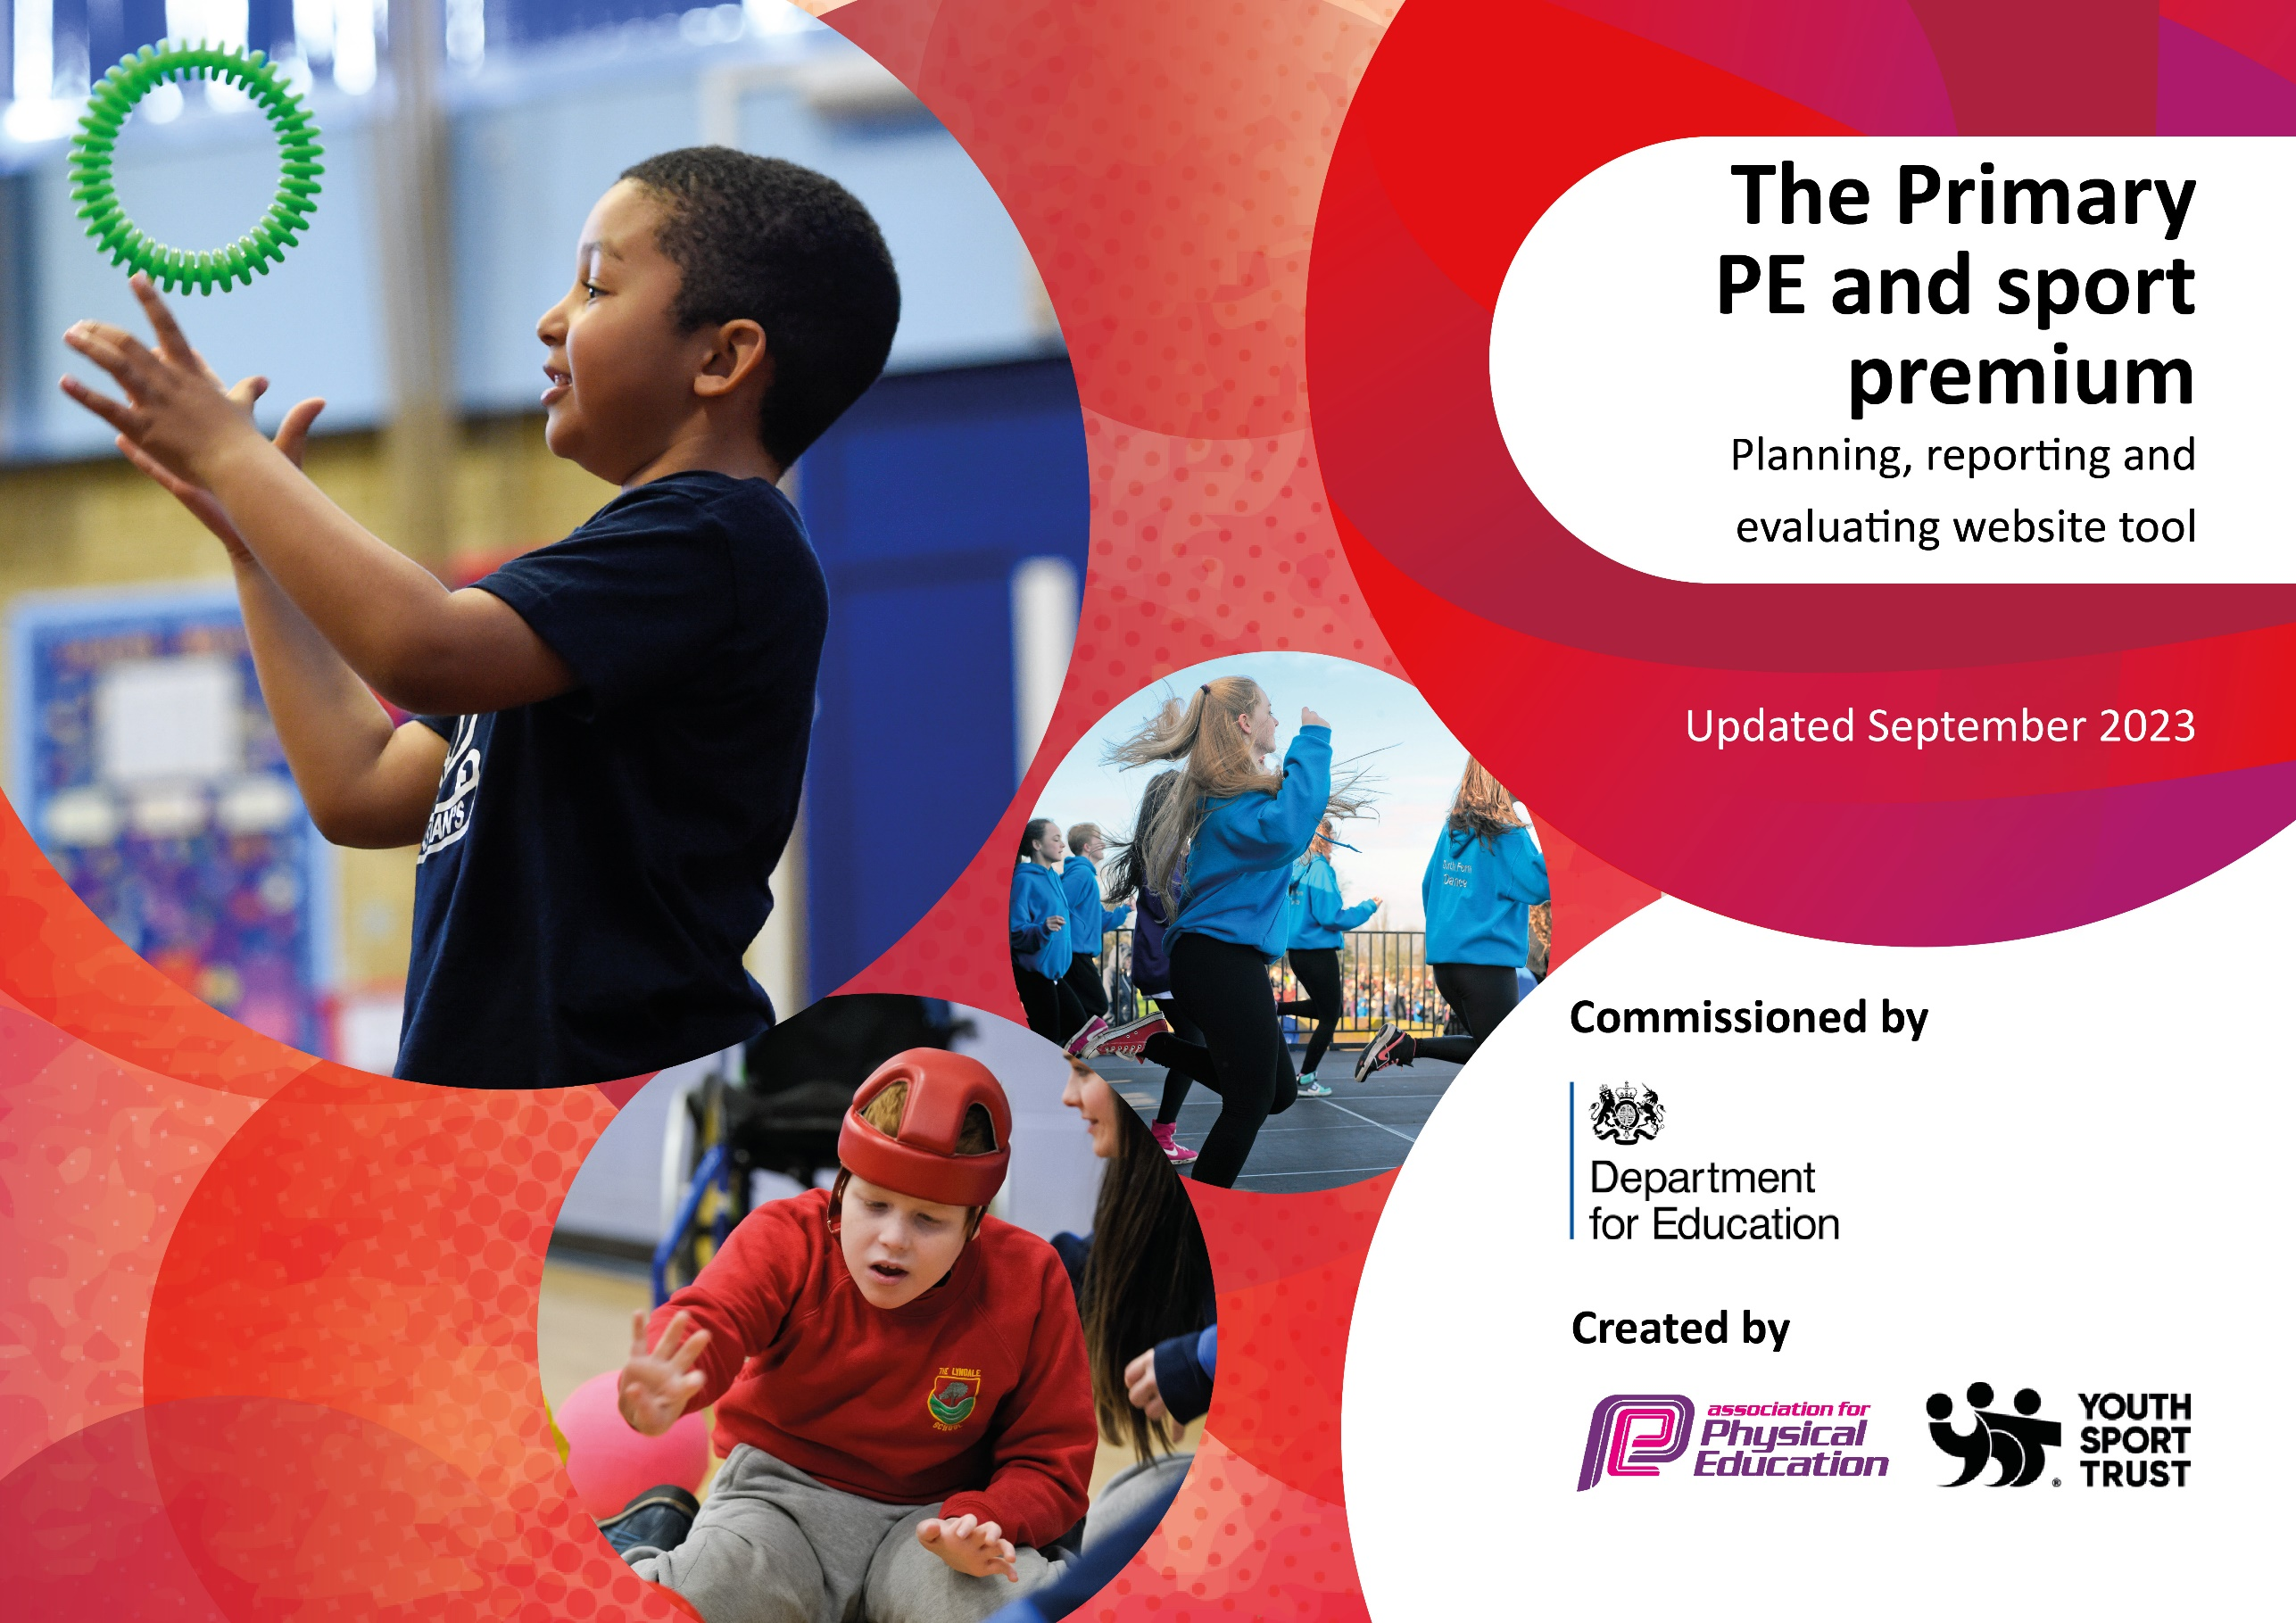

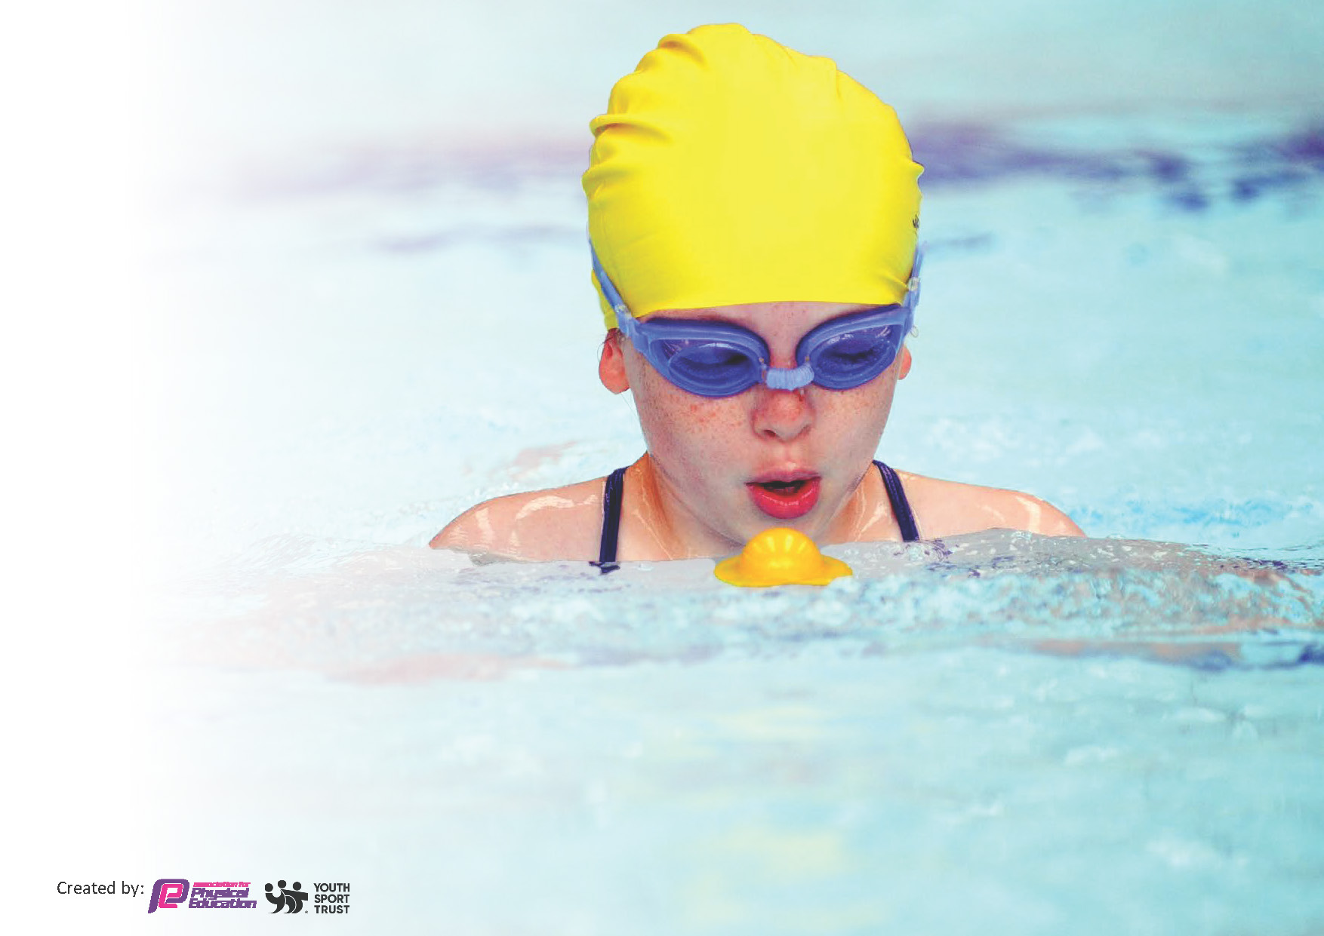
This template can be used for multiple purposes:
by:
- It enables schools to effectively plan their use of the Primary PE and sport premium
- It helps schools to meet the requirements (as set out in guidance) to publish information on their Primary PE and sport premium
- It will be an effective document to support Ofsted inspections enabling schools to evidence progress in Physical Education (PE) and evidence swimming attainment, which forms part of the PE National Curriculum. We would recommend schools consider
the Intent, Implementation and Impact of any spend, as examined within the Education Inspection Framework.

It is important that your grant is used effectively and based on school need.

Schools must use the funding to make additional and sustainable
improvements to the quality of the PE, School Sport and Physical Activity (PESSPA)
they offer. This means that you should use the Primary PE and sport premium to:

- Build capacity and capability within the school to ensure that improvements made now will benefit pupils joining the school in future years
- Develop or add to the PESSPA activities that your school already offers.

The Primary PE and sport premium should not be used to fund capital spend projects; the school’s core budget should fund these. Further detail on capital expenditure can be found in the updated Primary PE and sport premium guidance.

The Primary PE and sport premium guidance, outlines 5 key priorities that funding should be used towards. It is not

necessary that spending has to meet all the key priorities, you should select the priorities that you aim to use any funding towards.

Although completing this template is not a requirement for schools, schools are required to publish details of how they spend this funding. Schools must also outline what the impact this funding has had on pupils’ PE and sport participation and attainment and how any spending will be sustainable in the future. All funding must be spent by 31st July 2024.

The Department for Education has worked closely with the Association for Physical Education (afPE) and the Youth Sport Trust (YST) to develop this template and encourages schools to use it. This template is an effective way of meeting the reporting requirements of the Primary PE and sport premium.
Review of last year’s spend and key achievements (2022/2023)

We recommend you start by reflecting on the impact of current provision and reviewing your previous spend.

Activity/Action | Impact | Comments
Top up swimming lessons. Start lessons in Y2 (1 block). Extra lessons in Y3 and Y4. (1 term)  Membership of Forge Sports Partnership.  Sheffield United Premier League Stars  Staff supported by a dance teacher in dance lessons. | Children started lessons at a young age and were encouraged to go swimming outside of school lessons. Few children were scared of the water at a young age and less time was spent on water confidence. Children who have been at the school since Y2 are making good progress.  Y6 children trained as playground leaders and delivered games to KS1 children at playtime. They also planned and delivered sports days to KS1 and EYFS children.  PE lead attended PE conference and other CPD to keep up to date with changes.  Pupils took part in a range of competitions.  Quality of coaching was not as good as last year, therefore the impact was much less.  Standards in dance have improved across the school. | Swimming results affected by high mobility in school.  Some competitions not attended due to transport and staffing issues.  Most staff have improved their skills in teaching football working with coaches over the last 2 years. This year, it was felt that coaching was of a lower standard and staff could have delivered it better themselves. We haven’t signed up this year.  The teaching delivered by the dance specialist was good, but very difficult for non-specialist staff to deliver. This year she will work with staff to deliver lessons from the new scheme. This should be more sustainable.

Key priorities and Planning
This planning template will allow schools to accurately plan their spending.

Action – what are you planning to do | Who does this action impact? | Key indicator to meet | Impacts and how sustainability will be achieved? | Cost linked to the action
Introduce new scheme of work.  GetSet4PE.  Provide specialised support in dance.  Set up and manage  ‘Rackets Cubed’  Programme.  Maintain membership of school sports partnership.  Top up swimming lessons. Start lessons in Y2 (1 block). Extra lessons in Y3 and Y4. (1 term)  Provide taster days for new sports/activities. | Teaching staff  Pupils – as they will take part.  Teaching staff  4 teaching staff  30 Pupils Y4-Y6  PE Lead  Pupils  Pupils  Pupils | Key indicator 1: Increased confidence, knowledge and skills of all staff in teaching PE and sport  Key indicator 1: Increased confidence, knowledge and skills of all staff in teaching PE and sport  Key indicator 2: The engagement of all pupils in regular physical activity – the Chief Medical Officer guidelines recommend that all children and young people aged 5 to 18 engage in at least 60 minutes of physical activity per day, of which 30 minutes should be in school.  Key indicator 3:The profile of PE and sport is raised across the school as a tool for whole-school improvement.  Key indicator 4: Broader experience of a range of sports and activities offered to all pupils.  Key indicator 5: Increased participation in competitive sport.  Key indicator 2: The engagement of all pupils in regular physical activity – the Chief Medical Officer guidelines recommend that all children and young people aged 5 to 18 engage in at least 60 minutes of physical activity per day, of which 30 minutes should be in school.  Key indicator 4: Broader experience of a range of sports and activities offered to all pupils. | Staff will feel more confident in teaching all areas of the PE curriculum. Plans are detailed with clear teaching points, illustrations and video demonstrations.  Dance teacher will model how to deliver the units on dance and make appropriate adaptations. Teachers will see how to deliver the units of work and be able to deliver in the future.  Children involved will learn a new sport. (squash) They will be exposed to high level sports facilities and be encouraged to aim high and consider university in their future. They will walk for 30 mins each way to the centre and take part in 40 mins of squash. They will also be provided with a healthy meal and learn about healthy lifestyles, which will help them in the future.  More pupils taking part in competitions, both intra and inter.  More pupils meeting their daily physical activity goal, more pupils encouraged to take part in swimming out of school. School swimming results improve and children understand how to stay safe around water.  Pupils will have tried new sports that might interest them. Less active children might find a sport they enjoy. | £1375 cost for a 3 year subscription.  PE lead time out of class-supply cover for 1 day.  Equipment purchased to enable delivery of new curriculum.  £2000  Half day curriculum teaching for 3 half terms Oct- Easter.  £ 2000  PE lead time out of class-half a day to meet and plan with dance teacher.  Free for 6 weeks then £175 per 6 weeks.  Initially £1100 package. Extras for intra competitions.  £900  Money towards transport costs to competitions.  £500  PE lead supply cover for network meetings 1.5 days.  £5,870  2 extra blocks of swimming.  £700  Whole school taster days including sports day.

Key achievements 2023-2024
This template will be completed at the end of the academic year and will showcase the key achievements schools have made with their Primary PE and sport premium spending.

Activity/Action | Impact | Comments
Introduce new scheme of work.  GetSet4PE.  Provide specialised support in dance.  Set up and manage  ‘Rackets Cubed’  Programme.  Maintain membership of school sports partnership.  Top up swimming lessons. Start lessons in Y2 (1 block). Extra lessons in Y3 and Y4. (1 term)  Provide taster days for new sports/activities. | Staff willl feel more confident in teaching all areas of the PE curriculum. Plans are detailed with clear teaching points, illustrations and video demonstrations.  Dance teacher will model how to deliver the units on dance and make appropriate adaptations. Teachers will see how to deliver the units of work and be able to deliver in the future.  Children involved will learn a new sport. (squash) They will be exposed to high level sports facilities and be encouraged to aim high and consider university in their future. They will walk for 30 mins each way to the centre and take part in 40 mins of squash. They will also be provided with a healthy meal and learn about healthy lifestyles, which will help them in the future.  More pupils taking part in competitions, both intra and inter.  More pupils meeting their daily physical activity goal, more pupils encouraged to take part in swimming out of school. School swimming results improve and children understand how to stay safe around water.  Pupils will have tried new sports that might interest them. Less active children might find a sport they enjoy. | All staff have given positive feedback regarding the new scheme of work.  They found the video demonstrations really useful for their own development, as well as for the children.  Lessons were felt to be more imaginative and fun than the previous scheme. Children enjoyed the lessons and were able to use specific vocabulary.  Teachers also felt the knowledge and vocabulary was ambitious and could be used to make links with other curriculum areas. There’s a wide range of sports so some staff tried units they hadn’t previously taught, therefore increasing their subject knowledge.  Dance teacher delivered the lessons, with staff supporting. Some adaptations were made and noted by staff for next year.  Staff found it helpful to see how the dances could be built up to the finished performance. In some classes, parts of the dances were made more challenging to extend pupils.  The programme was set up and ran from Jan-June. 25-30 children from Y4-Y6 attended each week and really enjoyed the programme. They made good progress with their squash skills, as well as experiencing exciting STEM activities. They experienced the facilities of the university as well as being inspired by the students. The children were provided with healthy meals and got used to trying different foods. Unfortunately, there were difficulties with the amount of organization that was needed from us and a lack of coordination from the project leaders, which means it will be unsustainable next year.  Pupils took part in athletics and mini Olympic events at the EIS.  KS2 pupils took part in an orienteering festival provided by Forge staff.  KS2 pupils also took part in a Kin ball session as part of sports day.  Some SEND pupils took part in an ice skating event at Ice Sheffield and a team building events at EIS.  Y6 pupils received ‘sports leader’ training and led games for KS1 children at playtimes and sports day.  PE lead attended a PE conference and networking session provided by the partnership.  Children from Y2-Y5 took part in ‘Drowning prevention week’ learning crucial water safety information and skills. Children have enjoyed the lessons and are making good progress. Y6 results have improved from 18% to 38% this year. Some are now having additional lessons outside school.  Kin ball was introduced to KS2 classes as part of sports day.  Y4/Y5 attended Goodwin sports event, trying a range of different sports.  Y6 were introduced to lacrosse in an after school club.  Y3/Y6 went to Ice Sheffield for ice skating.  Y5/6 took part in activities like cycling, high ropes and low ropes at Thornbridge residential.

Swimming Data
Meeting National Curriculum requirements for swimming and water safety.
Priority should always be given to ensuring that pupils can perform safe self-rescue even if they do not fully meet the first two requirements of the National Curriculum programme of study

Question | Stats: | Further context  Relative to local challenges
What percentage of your current Year 6 cohort can swim competently, confidently and proficiently over a distance of at least 25 metres? | 38% | We have provided lessons for Y2 -Y5 for a number of years. Some children in Y6 haven’t been in our school since KS1, so haven’t had the same opportunity. High mobility impacts results.  Others have made good progress from being absolute beginners, who had never been in a swimming pool before starting the lessons.
What percentage of your current Year 6 cohort can use a range of strokes effectively [for example, front crawl, backstroke, and breaststroke]? | 38% | The groups who hadn’t covered 25m focused on front crawl and backstroke only.

What percentage of your current Year 6 cohort are able to perform safe self-rescue in different water-based situations? | 38% | All children took part in water safety lessons on personal survival skills as well as extra focus during drowning prevention week.  Those who have been at the school since Y2 have had these lessons each year.
If your schools swimming data is below national expectation, you can choose to use the Primary PE and sport premium to provide additional top-up sessions for those pupils that did not meet National Curriculum  requirements after the completion of core lessons. Have you done this? | Yes | We have bought 2 extra blocks of lessons and provided lessons for at least a term from Y2-Y5.
Have you provided CPD to improve the knowledge and confidence of staff to be able to teach swimming and water safety? | Yes/No | Not this year, but in previous years. (these staff are still attending the swimming lessons)  Staff go in the water to support children.  PE lead is a qualified swimming teacher and supports other staff to be able to assist with the teaching of swimming.

Signed off by:

Head Teacher: | Elizabeth Gray- Headteacher
Subject Leader or the individual responsible for the Primary PE and sport premium: | Corinne O’Neill- PE lead
Governor: | Joanna Saunders- Chair of governors
Date: | 26/7/24

