Can you make a list of all the things you’re looking forward to doing with your friends?

My Friendship

Fact-File

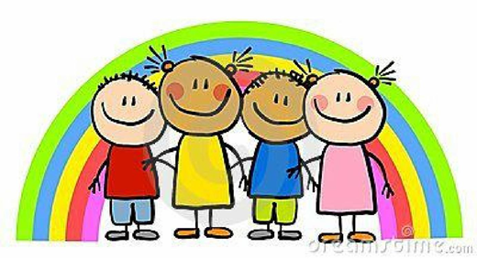

Think about all your friends and how wonderful it will be when you see them again!

Who are your friends?

What do you like doing with your friends?

What makes them a good friend?

What do your friends do to make you laugh?

