How do I help my body stay healthy?  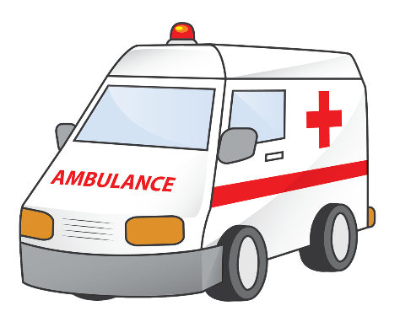 | Key objectives:  - Understand that active lifestyles, including regular exercise, can keep our bodies more healthy.  - Appreciate that some people live with disabilities or are differently abled.  - Understand that we can’t always have healthy bodies because sometimes we get ill or injured.  - Identify the components of a balanced diet.  - Understand that germs are spread by coughs, sneezes and physical contact with dirt and other people.  - Understand that we can prevent the spread of germs by washing our hands with soap especially when we go to the toilet, eat or are unwell.  - Understand that we can prevent tooth decay by brushing our teeth regularly.  - Identify common dangers at home and in the wider world.  - Know what to do in an emergency situation. | Key vocabulary  exercise  diet  brushing teeth  sleep  healthy  unhealthy  fruit  vegetables  energy  halal  kohsher  teeth  dentist  clean  wash  disease  germs  chemical  medicine  needles  railway  emergency  police  fire brigade  ambulance
How do we stop getting ill? | How do I decide what to eat?

