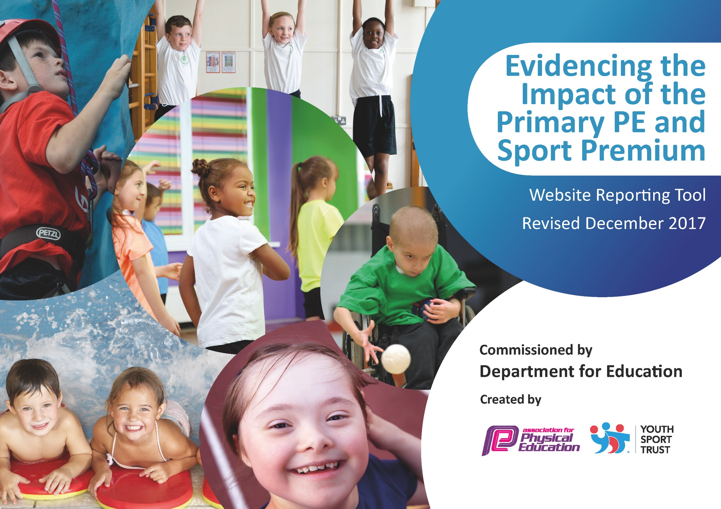

Schools must use the funding to make additional and sustainable improvements to the quality of PE and sport they offer. This means that you should use the Primary PE and Sport Premium to:

- develop or add to the PE and sport activities that your school already offers
- build capacity and capability within the school to ensure that improvements made now will benefit pupils joining the school in future years

Please visit gov.uk for the revised DfE guidance including the 5 key indicators across which schools should demonstrate an improvement. This document will help you to review your provision and to report your spend. DfE encourages schools to use this template as an effective way of meeting the reporting requirements of the Primary PE and Sport Premium.

We recommend you start by reflecting on the impact of current provision and reviewing the previous spend.
Under the Ofsted Schools Inspection Framework, inspectors will assess how effectively leaders use
the Primary PE and Sport Premium and measure its impact on outcomes for pupils, and how effectively governors hold them to account
for this.

Schools are required to publish details of how they spend this funding as well as on the impact it has on pupils’ PE
and sport participation and attainment.
We recommend regularly updating the table and
publishing it on your website as evidence
of your ongoing review into how you are using the money
to secure maximum, sustainable impact. To see an example of how to complete the table please click HERE.

Support for review and reflection - considering the 5 key indicators from DfE, what development needs are a priority for your setting and your students now and why? Use the space below to reflect on previous spend, identify current need and priorities for the future.

Key achievements to date: | Areas for further improvement and baseline evidence of need:
Pupils from Y2, Y3, Y4 and Y5 receive 1 term of weekly swimming lessons. Some pupils in Y2, Y3 and Y4 who were non-swimmers are already able to swim 10- 25m. Children love participating in swimming lessons and some children have started having lessons outside of school.  New sports introduced to the children: fencing taster day (Y1-Y6), squash-introductory lesson (Y4), cycling (balanceability - ongoing with groups of F2) , taekwondo –block of 6 lessons per class (Y1-Y6)  Balance bikes introduced to Foundation stage and staff trained in delivering the programme. This now forms part of regular practice.  Achieved Bronze Sports Award for School Games. (Gold in many areas)  Y6 pupils trained as play leaders and delivered activities in KS1 playtimes, clubs and sports day. They’ve developed leadership skills including, organisation of sports day, assisting at a weekly sports club and creating and leading games during KS1 playtimes.  Pupils Y1-Y6 competed in a range of competitions against other schools: athletics, basketball, handball, orienteering, cricket. Also virtual competitions and opportunities to compete against pupils within the school.  Y2 won the Forge Partnership sports hall athletics competition.  Y4 made it through to the City Finals for basketball, finishing 3rd.  Children have taken part in a running challenge to work to a progressive goal and improve fitness levels.  Active travel promoted through ‘Active Travel Challenge’. Approximately 95% of children participated.  Annual Dance Show attended by parents producing high quality dance routines from F2 to Y6, devised and created by pupils.  Previous gymnastics teaching is now embedded in the curriculum and regularly demonstrated in class assemblies.  Daily fun club sessions for identified pupils take place during lunch times.  All mealtime supervisors have been trained in leading playground activities and provide these for children on a daily basis.  Pupil interviews show that PE is one of the children’s favourite lessons. They can identify clearly what they like about PE and where their strengths are. 2 hours of PE take place weekly across school. | Due to high mobility summary results can mask individual progress. Work with the swimming service to provide more accurate data. Many children joining the school have little or no swimming experience. The vast majority of children don’t access swimming lessons outside of school. Process in place for future improved data  Provide further opportunities to try new activities. Some children attend local football clubs but don’t have access to a wider range of sports. The taster and block sessions were very well received by the children. Dance club and dance lessons for KS2, culminating in performance. Gold and Boccia taster sessions and series of Boccia lessons in Y2. Boccia particularly popular  Extend the balanceability programme into KS1. Core strength and gross motor skills of many children are low on entry to foundation stage. By the end of KS2 there are usually several children who still can’t ride a bike. Additional bikes and resources purchased. Long term staff illness has restricted implementation (pick up in Y1). Y1 and Y2 additional time with scooters at playtime  To achieve silver or gold standard in the future. Heat maps showing levels of activity throughout the week, are an area for development. The Active maths programme was not purchased last year due to other changes in the delivery of the maths curriculum. Activate is being used for younger children but alternatives for older children are needed. Heat map, go Noodle and Activate in use across school  Intra school competitions take place in PE lessons but need extending beyond this. Provide more intra school competitions. Orienteering competition now established across KS2. Sports Day provides additional key stage intra-school competition as well as during PE lessons and clubs within year groups. Further competitions across year groups area for future focus  All children are taking part but some classes haven’t yet established the challenge aspect. We need to provide more opportunities for personal challenge. Year 5s and Year 2s have completed this more than other year groups, including Running Club. Look at providing Running Club over lunchtime during next academic year  Personal challenge trialled during most recent sports day  Some aspects of Key indicator 3 did not take place and require further input this year. Dance lessons provided professional development for KS2 teachers. Boccia and Handball professional development provided for Year 2 and Year 4 staff. Cricket coaching and professional development provided for Year 5 teaching staff.

Meeting national curriculum requirements for swimming and water safety | Please complete all of the below*:
What percentage of your current Year 6 cohort swim competently, confidently and proficiently over a distance of at least 25 metres? | 30%
What percentage of your current Year 6 cohort use a range of strokes effectively [for example, front crawl, backstroke and breaststroke]? | 30%
What percentage of your current Year 6 cohort perform safe self-rescue in different water-based situations? | 30%
Schools can choose to use the Primary PE and Sport Premium to provide additional provision for swimming but this must be for activity over and above the national curriculum requirements. Have you used it in this way? | Yes
*Schools may wish to provide this information in April, just before the publication deadline.

Academic Year: 2018/19 | Total fund allocated: £17,270 | Date Updated: 12.11.18
Key indicator 1: The engagement of all pupils in regular physical activity – Chief Medical Officer guidelines recommend that primary school children undertake at least 30 minutes of physical activity a day in school.  Due to high levels of obesity in this area of Sheffield, this area is a priority for development. The school playground is very small and so school makes use of the sports hall at lunchtimes and also the local community green area when the weather permits. |  |  |  | Percentage of total allocation:
 |  |  |  | 29.5%
School focus with clarity on intended impact on pupils: | Actions to achieve: | Funding allocated: | Evidence and impact: | Sustainability and suggested next steps:
All pupils will be engaging in at least 30 minutes physical activity each day. Levels of obesity will start to decline and children will be active throughout lunchtimes as well as playtimes and other times of the day. | Children in Y6 trained as Play leaders to encourage active playtimes in KS1 and KS2 – training provided by Sports Partnership.  Introduce personal challenges to be run by sports leaders at playtime and purchase equipment..  Scrapstore Playpod resources replenished throughout the year. New meal-time supervisors trained internally, to play active, creative games with children.  Inventory of playground equipment for both main playground and EYFS playground carried out termly and resources purchased accordingly – Learning Mentor leading  PE subject leader to research alternatives to Activate for KS2, as a way to break up lessons and re-energise or calm pupils.  Continue to run Fun club at lunchtimes, providing additional PE activities for each class in KS1 and KS2 to participate in 30 minute sessions – led by TA.  Purchase further Bikeability resources for use in EYFS and KS1.  All classes to complete a heatmap showing levels of activity throughout the week. Staff to try and increase activity in lessons and consider more outdoor learning.  PE subject leader to organise after school clubs and lunch clubs. | School Partnership membership.  £1,100  £500  £2,000  £700  £800 | Y6 children have completed training and work with KS1 children on a rota during playtime, sharing games and encouraging children to join in. Younger children seen to enjoy playing with older children.  Y6 children also work with EYFS children on rota at lunchtime – encouraging children to join in and also to follow rules of games and turn take.  Scooters brought into school in KS2 after initial outside training – one additional playtime per week.  Informal observations at lunchtimes suggest that children are engaged and active throughout sessions.  Activate or Go Noodle being used across school being used across EYFS, KS1, Y3 and Y5.  Fun Club has been reviewed and will change for the next academic year – replace with Running Club or other.  Bikes purchased – long term illness has limited impact – plan for next year’s Y1 to catch-up and also timetabled for next year’s F2.  Y2 heat map has been completed and drama activities in literacy were done on the Ponderosa Park, among other active sessions.  Y5/Y6 girls football club after school.  Y5/Y6 cross country lunch club.  Y2/Y3 athletics club.  Y3/4 and Y5/6 dance club. | Play leaders trained annually as part of Y6 duties.  All Meal-time staff have been trained in order to maximise capacity end enable existing staff to support new staff in the future. Re-train/update training for MTSs  Carry out survey with KS1 children about favourite games with Play leaders in order to assess how many engage and participate and what attitudes are towards this.  Personal challenges is an area for development – purchase of electronic recording devices will improve this in the future.  Heatmaps for all classes in future – area for development to be completed early in the academic year.  Engage with the LA led Eat Smart Sheffield and work towards the Healthy Schools accreditation  Review focus of Fun-Club and amend, based on children’s feedback  Continue to develop the Gardening Club and purchase additional resources
Key indicator 2: The profile of PE and sport being raised across the school as a tool for whole school improvement.  The concepts of Learning Muscles and having a growth mindset are embedded in our school’s culture. As part of this, we always encourage children to do their best and improve as much as possible from their own particular starting point. This mindset links to every subject and is easily demonstrable via sport. The large majority of children join us with little or no experience of swimming. We strongly believe that every child should be able to swim and prioritise the development of this sport. |  |  |  | Percentage of total allocation:
 |  |  |  | 38.8%
School focus with clarity on intended impact on pupils: | Actions to achieve: | Funding allocated: | Evidence and impact: | Sustainability and suggested next steps:
To raise achievement in swimming by the end of KS2  To provide children with appropriate resources to support high quality learning.  To showcase and celebrate PE and Sport across school throughout the year.  To introduce neuromotor readiness for learning programme in F2 and Y1. | Purchase additional blocks for swimming, enabling all children from Y2 onwards to participate in swimming lessons.  PE subject leader carry out regular audits of equipment and replenishing stock termly.  Reversaboards for athletics to be purchased.  School kits for team events to be purchased.  Additional PE kits and plimsolls to use as spare for children to change into  PE subject leader organise celebratory events, e.g. Dance show, orienteering festival  Class teachers to continue to include elements of PE in class assemblies that are shared with the rest of the school, alongside sharing of learning of other subjects, e.g. maths and literacy.  Regular updates to be put on the website and school notice board.  Form sports committee and arrange meetings.  Appoint pupils to take on roles such as reporters/photographers at competitions.  F2 and Y1 staff to complete initial assessments on children, then implement intervention programme.  Lead by SENCO. | £4050  £500  £800  £250  £300  £800 release to attend training sessions | Results in swimming are gradually increasing in each year group. This may not be clear in Y6 results, as many children who have swimming lessons leave our school before they reach Y6.  Since a trained TA has been going swimming with the children, we have seen children’s confidence increase, particularly those children who were initially fearful of the water.  An additional TA has been trained re swimming and participates weekly.  Y2 swimming results show good progress already.  School now has it’s own equipment and is not reliant on secondary or other school, making it easier for school to organize events and training.  Feedback form Orienteering and Dance competitions very positive.  Dance and Orienteering events now established. Audience for Dance festival increased and very appreciative.  Children enjoy watching one another perform, both in groups or classes and as individuals.  PE skills have been shared in assemblies, e.g. vaulting, long jump, demonstrating to parents and other children what they are capable of achieving.  Notices promoting current clubs and events are on the notice board for all parents and children to see.  Y6 took a reporter to the girls’ football competition, who took photos and is currently writing a match report.  F2 initial assessments completed.  Year 1 to start assessments.  Run as a whole class activity during spring term – this was difficult to manage at times and did not focus enough on identified children. It has been adapted to be run as an intervention for the summer term across F2 and Y1 | Continue to prioritise swimming across school.  We have a designated TA who has completed swimming teacher training and goes with each class.  Reversaboards will be used every year for Y2 and Y6 athletics training and in other year groups for mini Olympics events.  Noticeboard has information but not always updated regularly.  Website reflects some of events but not all – area for development.  Reporting has not yet become established and embedded across the school and will be developed next year.  Members of school help at sports clubs and could be on the committee – this is more unofficial than not at the moment – this will focus on Y5 and Y6  Neuro-motor group is now being run as an intervention. Screen all F2 children and previous Y1 participants and identify those children with additional needs. Re-screening needed for participants  Participate in Primary Stars, delivered by SUFC
Action Plan and Budget Tracking
Capture your intended annual spend against the 5 key indicators. Clarify the success criteria and evidence of impact that you intend to measure to evaluate for students today and for the future.

Key indicator 3: Increased confidence, knowledge and skills of all staff in teaching PE and sport.  (This is an area that staff have benefitted from previously by having a series of gymnastics lessons, dance lessons and also orienteering lessons taught with them observing and learning. There has also been whole staff PDM training for these areas using previous Sports Premium funding. Therefore, it is not a priority for development.) |  |  |  | Percentage of total allocation:
 |  |  |  | 6.9%
School focus with clarity on intended  impact on pupils: | Actions to achieve: | Funding  allocated: | Evidence and impact: | Sustainability and suggested  next steps:
To continue to improve the quality of swimming lessons at the end of KS2  Develop the role of the PE subject leader to include informal observations of PE to support newer staff in order to maintain or raise the quality of PE taught to KS1 and KS2 pupils  Improve the quality of balance and bike riding skills across EYFS and KS1.  To improve cycling in KS2 and encourage more children to cycle to school. | TA to attend swimming training if available, to enable supporting children in the water.  Work closely with the swimming service to make changes to teaching and recording of data, to suit our specific needs.  Carry out survey of staff’s PE development needs in the autumn term to identify future needs of staff. Get support from the Sports Partnership where necessary.  PE subject leader to demonstrate or team teach PE with staff new to year groups in identified areas.  PE subject leader to informally observe colleagues in identified area of PE (several classes over two days).  SLT provide support for PE subject leader to monitor and develop assessment materials for PE.  HLTA to work with groups of F1 and F2 children regularly using balance bikes and accompanying activity suggestions.  HLTA to train new EYFS staff and Y1 TA in how to use balance bikes effectively and the principles behind using them.  Introduce Bikeability lessons in Y5 and Y6.  Organise for bike health checks so more children have safe bikes to use. | -  £400 release time for supply cover over series of lessons  £400 release time to cover class while observing  £400 | TA trained and now participating in lessons, particularly to support children with additional needs and/or anxiety re swimming.  Swimming service are now launching a new system 0 this is not yet available at Upperthorpe.  Staff needs identified: Dance, generally and individual requests for support with Hockey, athletics and handball.  Support provided by PE SL and modelling of skills required, rather than whole lessons demonstrated.  New Assessment scheme introduced, linking to other Foundation subjects.  Children in F2 taking part in balance bike training as part of provision.  A bike shed has been purchased and erected to enable easy access to bikeability resources.  Bike check was done in November and was well used by children and parents. Approximately 40 bikes were checked.  Second bike health check at beginning of summer term – very well attended. | Training could be extended to other TAs to increase capacity for supporting children with little or no swimming experience.  PE subject leader use the PE reflection books more diagnostically in future to support identification of areas for future development as well as evidence of achievement.  Observations of PE have not yet taken place. HT has observed outstanding practice by PE SL.  PE not yet focused on re update of assessment procedures (so far: Science, History, Geography, Art, French and Computing)  Long term absence of Bikeability trained TA has limited development of this – see above and next year’s plan for further details  Training cancelled by trainer and rescheduled for autumn term  Support NQTs in teaching of sport, including after school sessions.  Implement action plan for Y1 (2019-20) regarding bikeability and active learning  Reschedule Bike training  Create a progression of PE skills, based on Chris Quigley/Val Sabin for each year group and publish on website – allocate time two days (£400)
Key indicator 4: Broader experience of a range of sports and activities offered to all pupils.  Although very active, many of our children do not play a wide range of sports outside school. Football is a favourite, with a number of children attending a local club run by Zest (a community organisation based in the heart of the local area). Therefore, we offer opportunities for children to try other sports that they might be able to then continue outside of school in the future. |  |  |  | Percentage of total allocation:
 |  |  |  | 17.2%
School focus with clarity on intended  impact on pupils: | Actions to achieve: | Funding  allocated: | Evidence and impact: | Sustainability and suggested  next steps:
Children across KS1 and KS2 will have opportunities to try a new sport/s that they might not access outside school. | PE subject leader research and identify potential sports for each class to try, e.g. climbing  PE subject leader allocate sporting opportunities for children to access new sports throughout the course of the school year.  Pupil surveys in each class taken by sports committee members to establish interests of children.  Subsidise the Y5/Y6 trip to Thornbridge Outdoor Activity centre so that children can participate in bike riding, low and high ropes, orienteering and other outdoor activities.  Provide additional training for school staff accompanying children, if necessary. | £200 (for actions below as well)  £2,070  £700.00  (from amount above) | See above for additional sports made available to children.  Dance club and lessons throughout summer term for KS2 with dance specialist, resulting in improved performance and attitude of boys to dancing.  Pupil survey has taken place, indicating that pupils enjoyed new skills/sports practiced, e.g. Boccia and golf.  Gymnastics and Martial Arts identified for future clubs, if available. Gymnastic type activities are regularly seen on the playground at play and lunchtime.  Another successful trip to Thornbridge, including several children who had never ridden bikes previously. | When evaluation has taken place, consider whether to extend this club next year or whether to try another new sport.  (Future staff training needed for bikes and low ropes to replace member of staff leaving school)  Continue to provide additional taster days to engage children.  Scooter skills training for Y1/Y2  Dance club for Y2/Y3?  Taekwondo  Subsidise Whirlow?
Key indicator 5: Increased participation in competitive sport.  The Sports Partnership is closely connected with this key indicator as many events are organised between schools via this central link. We already participate in a range of competitions throughout the year and so further development of this is not a priority at the moment. We want to maintain the amount of competitions we participate in and possibly extend the range further in the future. We do not always win competitions but other schools and coaches regularly comment on what a fantastic attitude we have towards competitions and what great sports our children are; needless to say, we are immensely proud of this and want this attitude to continue. |  |  |  | Percentage of total allocation:
 |  |  |  | 7.5%
School focus with clarity on intended  impact on pupils: | Actions to achieve: | Funding  allocated: | Evidence and impact: | Sustainability and suggested  next steps:
To increase the opportunities all children in KS1 and KS2 have to participate in sporting events and competitions. | PE subject leader to attend Sports Partnership training and conferences. Long term plan in PE organized to reflect Sports Partnership competition programme.  PE subject leader to organise subsequent events and for teams to participate in a range of competitions. (stemming from the Sports Partnership – see KI 1 for funding information).  Each class has the opportunity to attend at least one sporting competition during the year – more if possible.  Classes to take part in at least one virtual competition.  Enter a B team in at least one competition.  Organise intra competitions between classes.  Introduce personal challenges.  Ensure all classes are recording data for running challenge.  Participation correlated by PE subject leader and shared on website. | £600  £700 (minibus or coach hire)  - (release time already accounted for above)  - (release time already accounted for above) | Several sports events entered through the sports partnership.  Y6 girls have attended a football competition.  Variety of compettions throughout the year, including: handball, athletics, basketball, hockey, mini-olympics, orienteering.  Each class has participated in at least one activity against other schools.  Y6 class have attended the Sports hall athletics competition.  Y2 won the athletics competition for the third year running.  Y5 made the city finals for basketball and came third.  Teams were compiled across the key stage for relevant events, such as orienteering.  Virtual competitions took place in KS1: mini-olympics and football.  Y3 participated in mini-olympics virtual competition.  There was a B team for hockey – Y4 team and Y3 B team.  Intra-class competitions – see above. Regular part of PE lessons. Mixed year groups competitions tale place in sports clubs. | Data for running challenge and personal challenge needs to be collected – iPads or other  The website needs to updated more regularly, linking with sports committee and events.  Build number of mixed year group competitions.  Use leftover Sport Partnership opportunity to run a key stage 2 intra-competition.

