Fish
goldfish  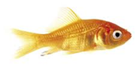 |  |  |  | cod  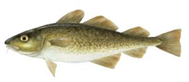
shark  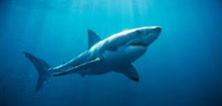 |  |  |  | salmon  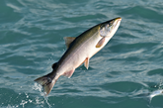
Reptiles
snake  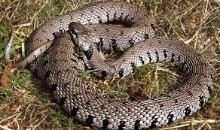 | lizard  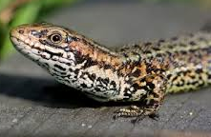 |  |  |  |  | crocodile  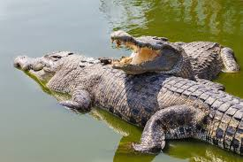
Birds
robin  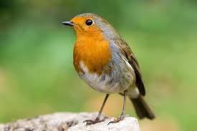 |  |  | owl  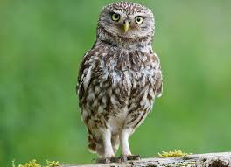
sparrow  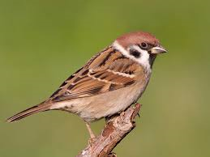 |  |  | woodpecker  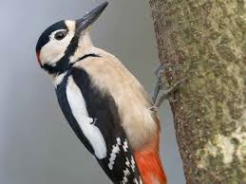
Amphibians
frog  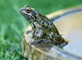 |  | toad  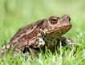 |  |  | newt  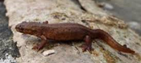
Mammals
cat  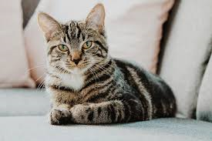 |  |  | dog  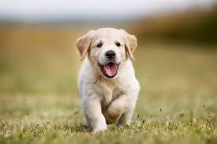
horse  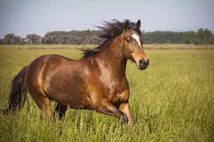 |  |  | sheep  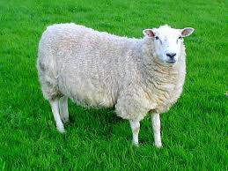
Animals including humans – Year 1
Key vocabulary to describe the features of different animals
head | body
eyes | ears
mouth | teeth
leg | tail
wing | claw
fin | scales
feathers | fur
beak | paws
hooves | hair

Carnivores
These are animals that eat other animals.
Herbivores  These are animals that only eat plants. | 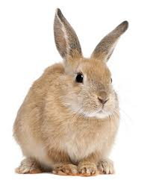
Omnivores  These are animals that eat plants and other animals. | 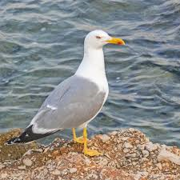 | 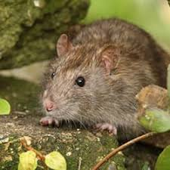

Parts of the human body
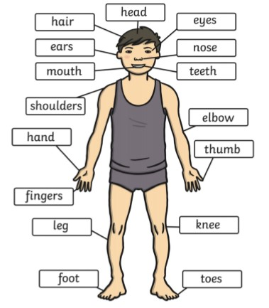

The 5 senses
Sense | Part of the body it is linked to
touch | 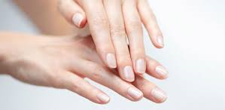 | fingers, hands, feet etc
sight | 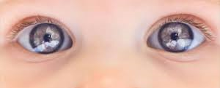 | eyes
smell | 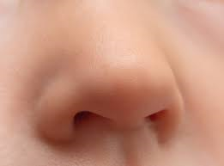 | nose
taste |  | tongue
hear | 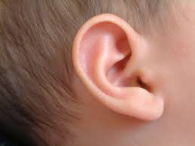 | ears

