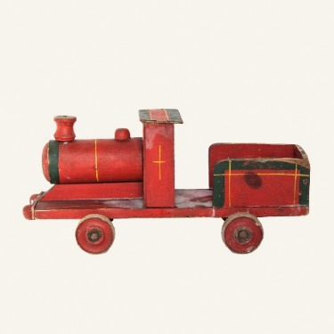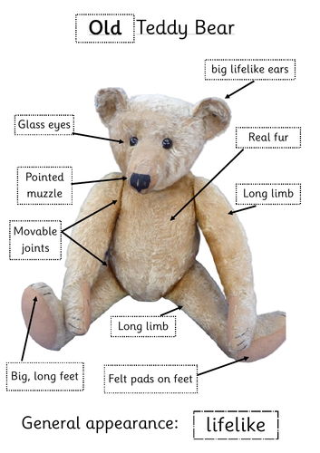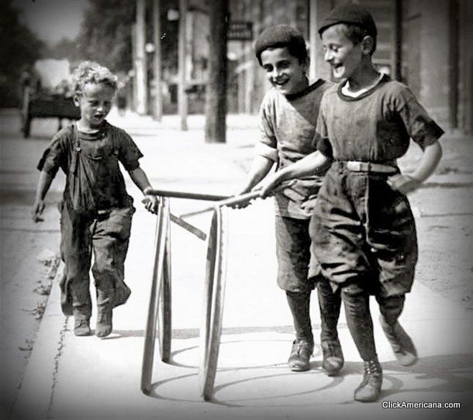

**Key Vocabulary and Terms:**

What is the same?

What is different?

old/er

new, modern

past, present

change

grow

young/er

museum

evidence

new-born, baby

toddler, child

A long time ago…

They used to be like…

When my grandma was little…

**How could you describe these toys?**

**What are our toys like today?**

**Who would play with these toys?**

**How can we tell these toys are old?**

**What toys did our grand parents play with and how do we know?**

**Key Objectives**

**Children:**

|  |
| --- |
| *\*develop an understanding of the terms*  *same and different and begin to use them*  *\*start to distinguish old and new*  *\*sort by colour, shape and material,*  *\*start to generate their own questions*  *\* describe how toys change as children grow older*  *\*match toys to children of the right age*  *\*give reasons why an obviously old toy is old, focusing on signs of wear and material, possibly design too.*  *\* describe changes across two generations.*  *\*use language such as. ‘They used to be like’, ‘When my Nan was a girl’*  *\*carry out a simple survey, interviewing grandparents and posing relevant questions.*  *\* show that they can identify old toys*  *\*make sensible selections of old toys which are clearly different from today’s*  *\*explain why their chosen toy is old*  *\* communicate their understanding of old toys and who would have played with them* |
|  |

**Toys through time!**

**Year 1**