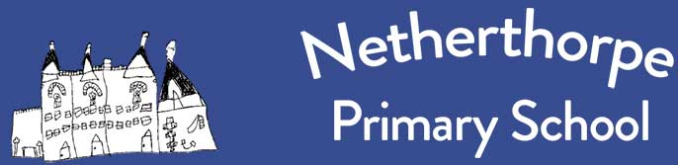
Reading and Phonics Statement

Reading is at the heart of everything we do at Netherthorpe Primary School. Reading and writing go hand in hand, and without one the other cannot flourish.
We know that decoding (reading) and encoding (spelling) are skills we need to equip our children with from the moment they come into school, and that is why we value our phonics provision.
The children are taught to decode and encode through explicit teaching and practice of the key skills and concepts:

Skills
• Blending
• Segmenting
• Phonic Manipulation

Concepts
• Letters are symbols that represent sounds
• Sounds can be spelled using 1,2 3 or 4 letters
• The same sound can be spelled in more than one way (fly, bright, hibernate, tie)
• Many spellings can represent more than one sound (head, seat, break)

We use Little Wandles at Netherthorpe: this programme is clear, consistent and cumulative. In Reception, Y1 and Y2, the children will have daily Little Wandles phonics lessons.
In KS1, we also use a range of phonetically decodable texts that are created by Little Wandles to match closely with the phonics being taught and to support the early stages of reading. Once pupils are confident, we encourage teachers to use quality texts to support the teaching of reading skills and deepen reading for pleasure, which is foundational and is at the heart of our school.
In KS2, we build on the skills acquired in KS1 by using a Reading Detectives approach. This helps to develop the breadth of reading pupils do alongside working on fluency and comprehension. Where appropriate, KS2 pupils may also continue to access phonics. In addition to this, our CLPE approach to writing puts quality texts and reading at the heart of our writing curriculum and further exposes pupils to chances to work on their reading fluency and comprehension in ways which support their written work.
We also value oracy above everything and use Rainbow Talk and principles from the U Can Centre to support our children in developing spoken language – this early language work complements and works alongside phonics.
