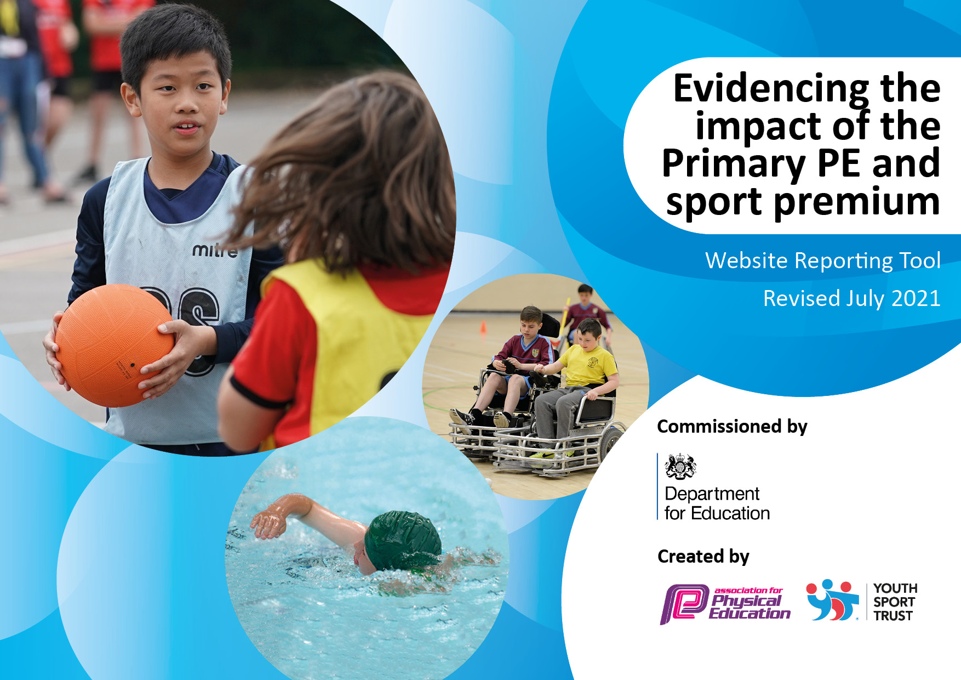
26
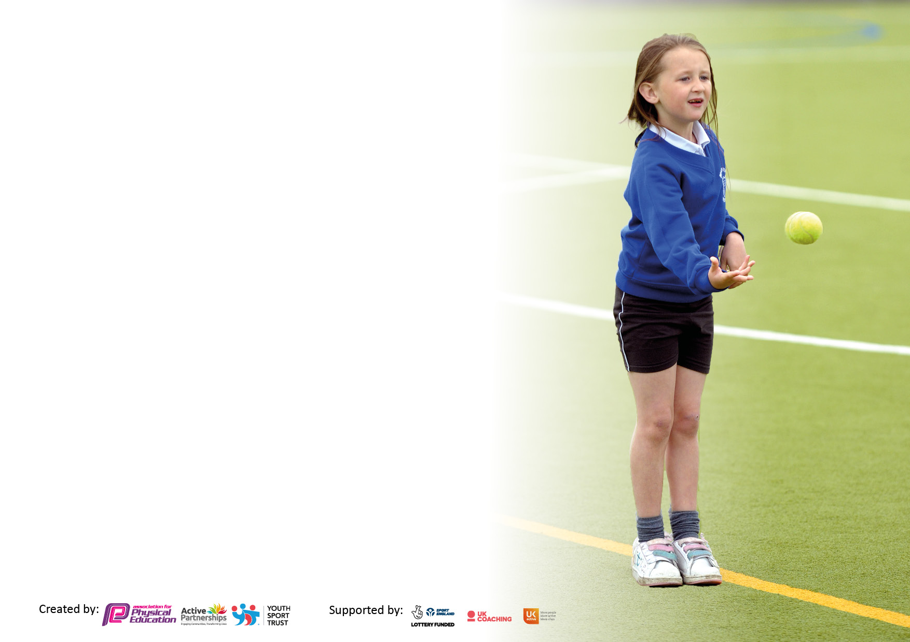

It is important that your grant is used effectively and based on school need. The Education Inspection Framework makes clear there will be a focus on ‘whether leaders and those responsible for governors all understand their respective roles and perform these in a way that enhances the effectiveness of the school’.

Under the Quality of Education Ofsted inspectors consider:
Intent - Curriculum design, coverage and appropriateness
Implementation - Curriculum delivery, Teaching (pedagogy) and Assessment
Impact - Attainment and progress

To assist schools with common transferable language this template has been developed to utilise the same three headings which should make your plans easily transferable between working documents.

Schools must use the funding to make additional and sustainable improvements to the quality of Physical Education, School Sport and Physical Activity (PESSPA) they offer. This means that you should use the Primary PE and sport premium to:

- Develop or add to the PESSPA activities that your school already offer
- Build capacity and capability within the school to ensure that improvements made now will benefit pupils joining the school in future years
- The Primary PE and sport premium should not be used to fund capital spend projects; the school’s budget should fund these.

Pleasevisitgov.ukfortherevisedDfEguidanceincludingthe5keyindicatorsacrosswhichschoolsshoulddemonstrate animprovement.Thisdocumentwillhelpyoutoreviewyourprovisionandtoreportyourspend.DfEencouragesschools to use this template as an effective way of meeting the reporting requirements of the Primary PE and sport premium.

We recommend you start by reflecting on the impact of current provision and reviewing the previous spend.

Schools are required to publish details of how they spend this funding, including any under-spend from 2019/2020, as well as on the impact it has on pupils’ PE and sport participation and attainment. All funding must be spent by 31st July 2022.

We recommend regularly updating the table and publishing it on your website throughout the year. This evidences your ongoing self-evaluation of how you are using the funding to secure maximum, sustainable impact. Final copy must be posted on your website by the end of the academic year and no later than the 31st July 2021. To see an example of how to complete the table please click HERE.
Created by: Supported by:

Details with regard to funding
Please complete the table below.

Total amount carried over from 2019/20 | £
Total amount allocated for 2020/21 | £
How much (if any) do you intend to carry over from this total fund into 2021/22? | £
Total amount allocated for 2021/22 | £ 17700
Total amount of funding for 2022/23. To be spent and reported on by 31st July 2023. | £ 17700
Swimming Data
Please report on your Swimming Data below.

Meeting national curriculum requirements for swimming and water safety.

N.B. Complete this section to your best ability. For example you might have practised safe self-rescue techniques on dry land which you can then transfer to the pool when school swimming restarts.
Due to exceptional circumstances priority should be given to ensuring that pupils can perform safe self-rescue even if they do not fully meet the first two requirements of the NC programme of study
What percentage of your current Year 6 cohort swim competently, confidently and proficiently over a distance of at least 25 metres?  N.B. Even though your pupils may swim in another year please report on their attainment on leaving primary school at the end of the summer term 2020.  Please see note above | 26%
What percentage of your current Year 6 cohort use a range of strokes effectively [for example, front crawl, backstroke and breaststroke]?  Please see note above | 4%
What percentage of your current Year 6 cohort perform safe self-rescue in different water-based situations? | 100%
Schools can choose to use the Primary PE and sport premium to provide additional provision for swimming but this must be for activity over and above the national curriculum requirements. Have you used it in this way? | Yes

Action Plan and Budget Tracking
Capture your intended annual spend against the 5 key indicators. Clarify the success criteria and evidence of impact that you intend to measure to evaluate for pupils today and for the future.

Academic Year: 2022/23 | Total fund allocated: £17, 700 | Date Updated: 16.11.22
Key indicator 1: The engagement of all pupils in regular physical activity – Chief Medical Officers guidelines recommend that primary school pupils undertake at least 30 minutes of physical activity a day in school |  |  |  | Percentage of total allocation:
 |  |  |  | £1900 10%
Intent | Implementation |  | Impact
Your school focus should be clear what you want the pupils to know and be able to do and about  what they need to learn and to  consolidate through practice: | Make sure your actions to achieve are linked to your intentions: | Funding allocated: | Evidence of impact: what do pupils now know and what can they now do? What has changed?: | Sustainability and suggested next steps:
All pupils will be engaging in 30-60 minutes physical activity each day. Levels of obesity will start to decline and children will be active throughout lunchtimes as well as playtimes and other times of the day. | Children in Y6 to be trained as Play leaders to encourage active playtimes in KS1 – training provided by Sports Partnership.  KS1 children to give feedback on their favourite games,  so play leaders can plan future activities.  Introduce a range of personal challenges for children to work towards at playtimes and lunchtimes.  Inventory of playground equipment for each bubble, carried out termly and resources purchased accordingly – Learning Mentor leading. KS2 children to have a say in how their allocation is spent. (pupil voice)  Purchase an outdoor speaker for dance and skipping activities in the playground. (carried over)  Scrapstore resources delivered regularly throughout year  All classes to complete a heatmap showing levels of activity throughout the week. Staff to try and increase activity in lessons and consider more outdoor learning.  PE coordinator to monitor use of Activate etc and continue to look for variations.  Engage with the LA led Eat Smart Sheffield and work towards the Healthy Schools accreditation  PE subject leader to organise after school clubs when possible.  Continue to develop the Gardening Club and purchase additional resources.  Continue links with community gardening group. | See Forge Partnership below  £300  £300  £1100  £ | Y6 training for playleaders completed. | Made contact with forest school. Follow up next year.
Key indicator 2: The profile of PESSPA being raised across the school as a tool for whole school improvement |  |  |  | Percentage of total allocation:
 |  |  |  | £9479 50%
Intent | Implementation |  | Impact
Your school focus should be clear what you want the pupils to know and be able to do and about  what they need to learn and to  consolidate through practice: | Make sure your actions to achieve are linked to your intentions: | Funding allocated: | Evidence of impact: what do pupils now know and what can they now do? What has changed?: | Sustainability and suggested next steps:
To raise achievement in swimming by the end of KS2.  By swimming regularly over a series of years, pupils will develop good swimming skills. They will develop confidence and will feel encouraged to participate in out of school swimming activities.  The amount of children being able to swim unaided for a sustained distance will continue to increase year on year.  To provide children with appropriate resources to support high quality learning.  To showcase and celebrate PE and Sport across school throughout the year. | Purchase additional blocks for swimming, enabling all children from Y2- Y5 to participate in swimming lessons.  PE lead to work closely with school swimming service to improve quality of lessons and progress of swimmers.  PE lead will support class teachers to deliver water safety lessons in class, prior to swimming lessons, to increase the amount of time in the water.  PE subject leader carry out regular audits of equipment and replenishing stock termly Focus on improving gymnastics equipment  PE subject leader to research and share good practice for use of interactive whiteboard in PE lessons.  PE subject leader to organise celebratory events in bubbles or virtually. e.g. Dance show, orienteering festival  Class teachers to celebrate achievements in PE in class assemblies, giving certificates. Share videos of performances with another class.  Regular updates to be put on the website and school notice board.  Form sports committee and give tasks to class sports leaders in KS2. | £  £200  £3000

Key indicator 3: Increased confidence, knowledge and skills of all staff in teaching PE and sport |  |  |  | Percentage of total allocation:
 |  |  |  | £6210 33%
Intent | Implementation |  | Impact
Your school focus should be clear | Make sure your actions to | Funding | Evidence of impact: what do | Sustainability and suggested
what you want the pupils to know | achieve are linked to your | allocated: | pupils now know and what | next steps:
and be able to do and about | intentions: |  | can they now do? What has
what they need to learn and to |  |  | changed?:
consolidate through practice:
To continue to improve the quality of swimming lessons and results at the end of KS2  Continue to develop the role of the PE subject leader, in order to maintain or raise the quality of PE taught to KS1 and KS2 pupils | Further TAs to attend swimming training if available, to enable supporting of nervous children in the water.  Work closely with the swimming service to make changes to teaching and recording of data, to suit our specific needs.  PE lead to support staff in delivering water safety aspects of the curriculum in school.  Prioritise year groups to swim, considering blocks missed through covid.  Work with the sports partnership to provide curriculum support in gymnastics. (Y5 and Y3)  Class teachers to work with a dance teacher to develop subject confidence. Teachers from Y1-6 to receive half a term of modelled teaching.  Participate in Primary Stars, delivered by SUFC. Teachers from Y1-Y4 to receive half a term of modelled teaching. Y5/6 to receive one term.  PE subject leader to support staff in teaching of PE.  SLT provide support for PE subject leader to monitor and develop use of PE reflection books and assessment. | £1720 (see also other aspects of sports partnership, e.g. competitions and training)  £2050  £3312  £200  (see SL support time above)
Key indicator 4: Broader experience of a range of sports and activities offered to all pupils |  |  |  | Percentage of total allocation:
 |  |  |  | £1000 5%
Intent | Implementation |  | Impact
Your school focus should be clear | Make sure your actions to | Funding | Evidence of impact: what do | Sustainability and suggested
what you want the pupils to know | achieve are linked to your | allocated: | pupils now know and what | next steps:
and be able to do and about | intentions: |  | can they now do? What has
what they need to learn and to |  |  | changed?:
consolidate through practice:
Children across KS1 and KS2 will have opportunities to try a new sport/s that they might not access outside school.  Children will feel proud of their achievements and may decide to pursue these sports or activities outside of school.  Children will have the opportunity to participate in unusual activities that they are unable to experience within school. They will have opportunities to challenge themselves and develop new skills and self-confidence | PE subject leader to identify potential sports for each class to try. Eg yoga, lacrosse and whole school taster days.  Pupil surveys in each class taken by sports committee members to establish interests of children.  Work with the university and Zest where possible, to set up taster sessions and clubs.  Subsidise the Y5/Y6 residential trip to Thornbridge Outdoor Activity centre so that children can participate in bike riding, low and high ropes, orienteering and other outdoor activities.  Organise for forest school activities on the Ponderosa. | £1000  £500

Key indicator 5: Increased participation in competitive sport |  |  |  | Percentage of total allocation:
 |  |  |  | £400 2%
Intent | Implementation |  | Impact
Your school focus should be clear | Make sure your actions to | Funding | Evidence of impact: what do | Sustainability and suggested
what you want the pupils to know | achieve are linked to your | allocated: | pupils now know and what | next steps:
and be able to do and about | intentions: |  | can they now do? What has
what they need to learn and to |  |  | changed?:
consolidate through practice:
To increase the opportunities all children in KS1 and KS2 have to participate in sporting events and competitions. | PE subject leader to attend Sports Partnership training and conferences, if available. If not, to maintain regular contact with the partnership team via email and phone.  Long term plan in PE organized to reflect Sports Partnership competition programme.  PE subject leader to organise for classes to participate in a range of virtual competitions. (stemming from the Sports Partnership – see KI 1 for funding information).  Plan intra competitions between different classes, within key stage.  Children to take part in class competitions at the end of units of work.  Introduce further personal challenges for children to work on within their class/key stage.  Ensure all classes are recording data for the running challenge and presenting certificates. | £300  (see SL organisation time above)

Signed off by
Head Teacher: | Elizabeth Gray
Date:
Subject Leader: | Corinne O’Neill
Date:
Governor: | Kathryn Rangeley
Date:

