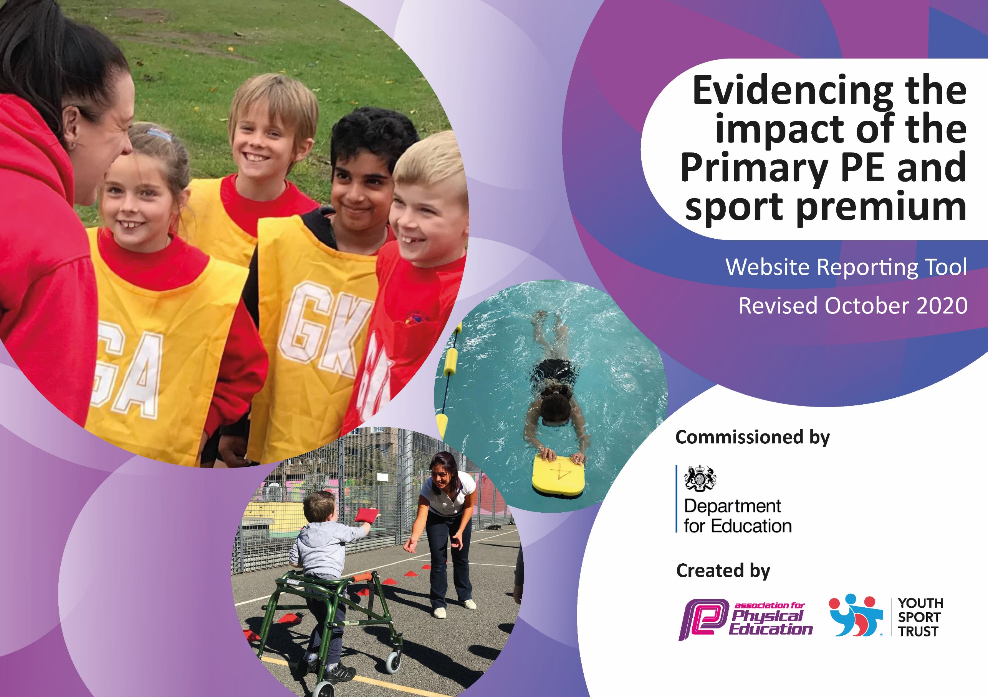
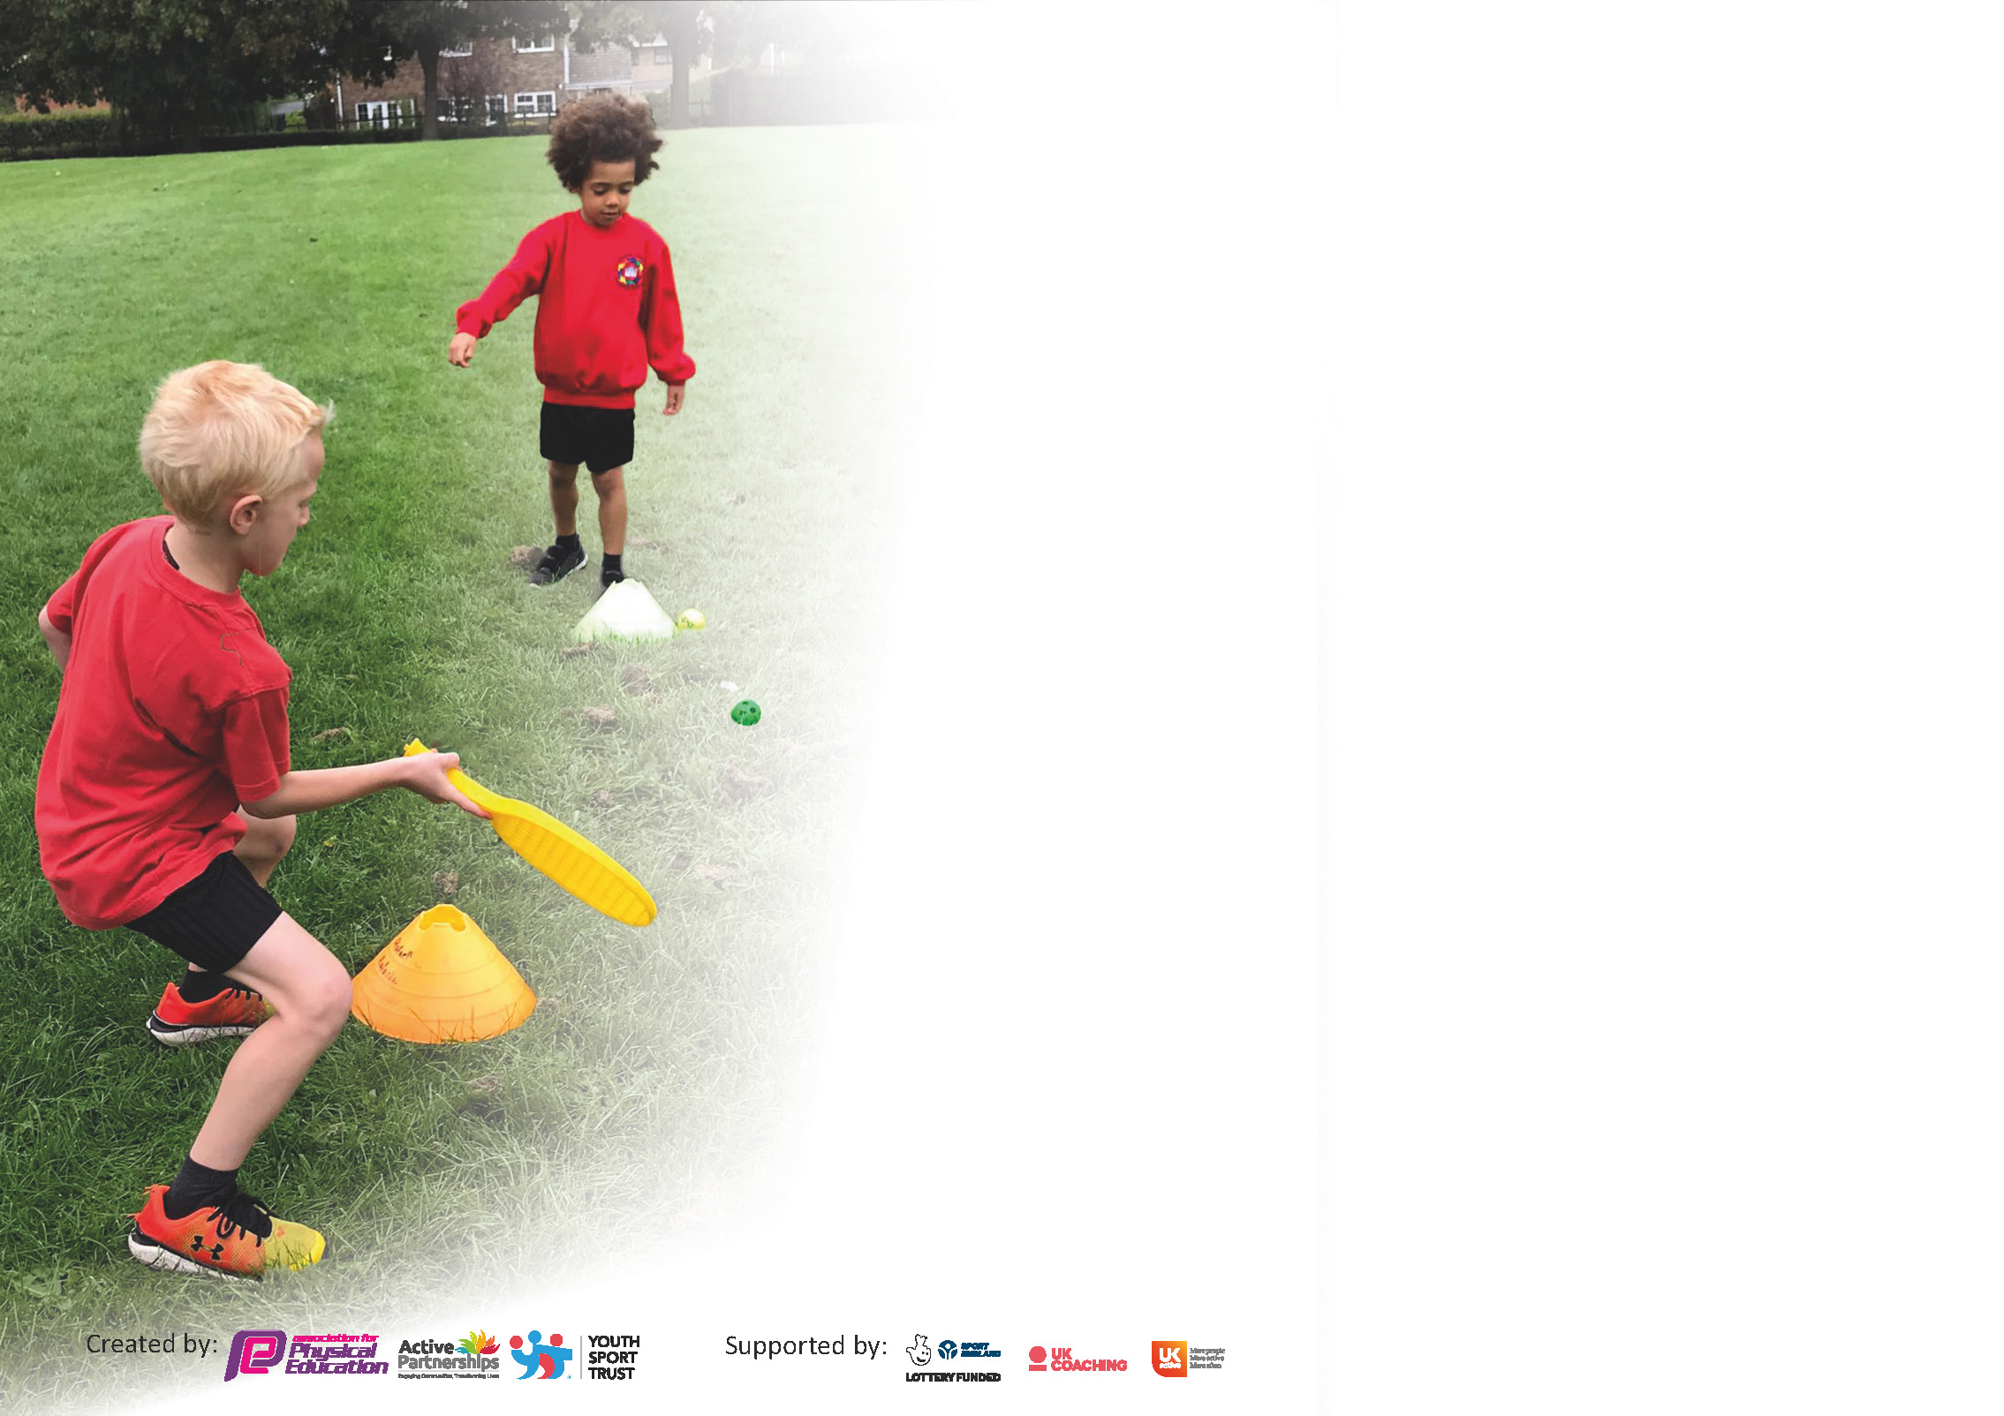

It is important that your grant is used effectively and based on school need. The Education Inspection Framework (Ofsted 2019 p64) makes clear there will be a focus on ‘whether leaders and those responsible for governors all understand their respective roles and perform these in a way that enhances the effectiveness of the school’.

Under the Quality of Education criteria (p41) inspectors consider the extent to which schools can articulate their curriculum (INTENT), construct their curriculum (IMPLEMENTATION) and demonstrate the outcomes which result (IMPACT).

To assist schools with common transferable language this template has been developed to utilise the same three headings which should make your plans easily transferable between working documents.

Schools must use the funding to make additional and sustainable improvements to the quality of Physical Education, School Sport and Physical Activity (PESSPA) they offer. This means that you should use
the Primary PE and sport premium to:

- Develop or add to the PESSPA activities that your school already offer
- Build capacity and capability within the school to ensure that improvements made now will benefit pupils joining the school in future years

Please visit gov.uk for the revised DfE guidance including the 5 key indicators across which schools should demonstrate an improvement. This document will help you to review your
provision and to report your spend. DfE encourages schools to use this template as an effective way of meeting the reporting requirements of the Primary PE and sport premium.

We recommend you start by reflecting on the impact of current provision and reviewing the previous spend.

Schools are required to publish details of how they spend this funding as well as on the impact it has on pupils’ PE and sport participation and attainment by the end of the summer term or by 31st July 2021 at the latest.

** In the case of any under-spend from 2019/20 which has been carried over this must be used and published by 31st March 2021.

We recommend regularly updating the table and publishing it on your website throughout the year. This evidences your ongoing self-evaluation of how you are using the funding to secure maximum, sustainable impact. Final copy must
be posted on your website by the end of the academic year and no later than the 31st July 2021. To see an example of how to complete the table please click HERE.
Created by: Supported by:

Please note: Although there has been considerable disruption in 2020 it is important that you publish details on your website of how you spend the funding - this is a legal requirement.
Support for review and reflection - considering the 5 key indicators from DfE, what development needs are a priority for your setting and your pupils now and why? Use the space below to reflect on previous spend and key achievements and areas for development.

N.B. In this section you should refer to any adjustments you might have made due to Covid-19 and how these will influence further improvement.
Key achievements to date until July 2020: | Areas for further improvement and baseline evidence of need:
Pupils from Y2, Y3, Y4 and Y5 receive 1 term of weekly swimming lessons. Some pupils in Y2, Y3 and Y4 who were non-swimmers are already able to swim 10- 25m. Children love participating in swimming lessons and some children have started having lessons outside of school. 2 TAs have now received training. The water safety element is now covered in school.  New sports introduced to the children: golf taster session (Y2-Y6), introduction to rugby and ultimate frisby (Y4 and Y5), boccia taster session (Y2-Y6) Y2 block of 4 lessons in boccia, street dance –block of 6 lessons per class (Y3-Y6) plus Y5 lacrosse club.  Balance bikes programme continued in Foundation stage by trained TA. This now forms part of regular practice. Additional bikes and resources bag purchased, including a pedal bike.  Scooter training was delivered in KS1 and children have specific scooter playtime each week.  Achieved Silver Sports Award for School Games. (Gold in many areas)  Heat map completed in Y2 and trialed more active lessons across the curriculum.  Each year Y6 pupils trained as play leaders and delivered activities in KS1 playtimes, clubs and sports day. They’ve developed leadership skills including, organisation of sports day, assisting at a weekly sports club and creating and leading games during KS1 playtimes.  Pupils Y1-Y6 competed in a range of competitions against other schools: athletics, basketball, handball, orienteering, cricket. Also virtual competitions and opportunities to compete against pupils within the school. KS2 took part in an intra-orienteering competition on the Ponderosa. This will now be an annual event.  Y2 won the Forge Partnership sports hall athletics competition.  Y4 made it through to the City Finals for basketball, finishing 4th.  Children have taken part in a running challenge to work to a progressive goal and improve fitness levels.  Personal challenges trialed at sports Day.  Active travel promoted through ‘Active Travel Challenge’. Approximately 95% of children participated.  Annual Dance Show attended by parents producing high quality dance routines from F2 to Y6, devised and created by pupils.  Previous gymnastics teaching is now embedded in the curriculum and regularly demonstrated in class assemblies.  Daily fun club sessions for each class take place during lunch times.  All mealtime supervisors have been trained in leading playground activities and provide these for children on a daily basis. Playpod encourages creative and active play.  Pupil interviews show that PE is one of the children’s favourite lessons. They can identify clearly what they like about PE and where their strengths are. 2 hours of PE take place weekly across school.  Dance lessons provided professional development for KS2 teachers. Boccia and Handball professional development provided for Year 2 and Year 4 staff. Cricket coaching and professional development provided for Year 5 teaching staff. | Due to high mobility summary results can mask individual progress. Many children joining the school have little or no swimming experience. The vast majority of children don’t access swimming lessons outside of school. PE lead to work closely with the swimming service to ensure accurate reporting. PE lead to attend swimming lessons to monitor the quality of the service. (if/when safe to do so)  Provide further opportunities to try new activities. A few children attend local football clubs but the majority don’t have access to a wider range of sports.  Extend the balance-ability programme into KS1. Core strength and gross motor skills of many children are low on entry to foundation stage. By the end of KS2 there are usually several children who still can’t ride a bike. Purchase pedal bikes as a progression for Y1 pupils. Conduct pupil survey as to who can ride a bike/has a bike. Look into training for KS2 pupils.  To work towards gold standard in the future. Heat maps showing levels of activity throughout the week, are an area for development. Activate is being used for younger children and alternatives such as Go-Noodle and Super Movers in KS2. A list of activities needs compiling for staff and monitoring of activities in KS2.  Intra school competitions take place in PE lessons, clubs and sports day, but need extending beyond this. Provide more intra school competitions within bubbles.  All children are taking part but some classes haven’t yet established the challenge aspect. Personal bests need to be recorded and passed up to next class. Sports leaders to set up personal challenges virtually for KS1 at playtimes.  Some aspects of Key indicator 3 did not take place and require further input this year.  School to continue work with Premier League stars programme, allowing professional development for teachers in football.  Also curriculum support from the sports partnership in gymnastics teaching which was identified as an area where staff felt less confident.

Did you carry forward an underspend from 2019-20 academic year into the current academic year? YES *

If any funding from the academic year 2019/20 has been carried over you MUST complete the following section. Any carried over funding MUST be spent by 31 March 2021.
Academic Year: September 2020 to March 2021 | Total fund carried over: £1,950 | Date Updated: 20.11.20  And again on 10.03.21
What Key indicator(s) are you going to focus on? |  |  |  | Total Carry Over Funding:
 |  |  |  | £1,950
Intent | Implementation |  | Impact
Your school focus should be clear how you want to impact on your pupils  To showcase and celebrate PE and Sport across school throughout the year  Children will have the opportunity to participate in unusual activities that they are unable to experience within school. They will have opportunities to challenge themselves and develop new skills and self-confidence  All pupils will be engaging in 30-60 minutes physical activity each day. Levels of obesity will start to decline and children will be active throughout lunchtimes as well as playtimes and other times of the day  Children will benefit from better sound from IWB in sports hall | Make sure your actions to achieve are linked to your intentions:  Additional dance lessons for all children from Y1 to Y6 and dance videos made for children to access if self-isolating/lockdown  Purchase of additional balance bikes to extend programme into Y1 for children who missed out due to lockdown  Resources bought to enable each bubble to have own set of playground equipment  Soundbar to increase volume of sound in sports hall | Carry over funding allocated:  £880 – now spent  £800 now spent  £200  £150 | Evidence of impact: How can you measure the impact on your pupils; you may have focussed on the difference that PE, SS & PA have made to pupils re-engagement with school. What has changed?: | Sustainability and suggested next steps and how does this link with the key indicators on which you are focussing this academic year?:

Meeting national curriculum requirements for swimming and water safety.

N.B Complete this section to your best ability. For example you might have practised safe self-rescue techniques on dry land.
What percentage of your current Year 6 cohort swim competently, confidently and proficiently over a distance of at least 25 metres?  N.B. Even though your pupils may swim in another year please report on their attainment on leaving primary school at the end of the summer term 2020. | 66%
What percentage of your current Year 6 cohort use a range of strokes effectively [for example, front crawl, backstroke and breaststroke]? | 69%
What percentage of your current Year 6 cohort perform safe self-rescue in different water-based situations? | 100%
Schools can choose to use the Primary PE and sport premium to provide additional provision for swimming but this must be for activity over and above the national curriculum requirements. Have you used it in this way? | Yes

Action Plan and Budget Tracking
Capture your intended annual spend against the 5 key indicators. Clarify the success criteria and evidence of impact that you intend to measure to evaluate for pupils today and for the future.

Academic Year: 2020/21 | Total fund allocated: £ 17,720 | Date Updated: 20.011.20 and 10.03.21
Key indicator 1: The engagement of all pupils in regular physical activity – Chief Medical Officers guidelines recommend that primary school pupils undertake at least 30 minutes of physical activity a day in school |  |  |  | Percentage of total allocation:
 |  |  |  | £1770 c10%
Intent | Implementation |  | Impact
Your school focus should be clear what you want the pupils to know and be able to do and about  what they need to learn and to  consolidate through practice: | Make sure your actions to achieve are linked to your intentions: | Funding allocated: | Evidence of impact: what do pupils now know and what can they now do? What has changed?: | Sustainability and suggested next steps:
All pupils will be engaging in 30-60 minutes physical activity each day. Levels of obesity will start to decline and children will be active throughout lunchtimes as well as playtimes and other times of the day. | Children in Y6 to be trained as Play leaders to encourage active playtimes in KS1 – training provided by Sports Partnership.  Play leaders to create videos for KS1 while Covid-19 restrictions are in place.  KS1 children to give feedback on their favourite games, so play leaders can plan future activities.  Introduce a range of personal challenges for children to work towards at playtimes and lunchtimes.  Inventory of playground equipment for each bubble, carried out termly and resources purchased accordingly – Learning Mentor leading. KS2 children to have a say in how their allocation is spent. (pupil voice)  Yearly subscription to Playpod for resources  Purchase an outdoor speaker for dance and skipping activities in the playground.  PE subject leader to research further ideas to break up lessons and re-energise or calm pupils throughout the day. Produce a list of activities/resources for staff to access.  More staff to be trained in Balanceability in EYFS and KS1.  All classes to complete a heatmap showing levels of activity throughout the week. Staff to try and increase activity in lessons and consider more outdoor learning.  Engage with the LA led Eat Smart Sheffield and work towards the Healthy Schools accreditation  PE subject leader to organise after school clubs where possible, including virtual activities. Also, to provide activities for bubbles who might be self-isolating at home.  Continue to develop the Gardening Club and purchase additional resources.  Set up links with community gardening group. | (see Sports Partnership below)  (see last year’s funding above)  £1000  £250  (see last year’s funding above)  £220  £300
Key indicator 2: The profile of PESSPA being raised across the school as a tool for whole school improvement  The concepts of Learning Muscles and having a growth mindset are embedded in our school’s culture. As part of this, we always encourage children to do their best and improve as much as possible from their own particular starting point. This mindset links to every subject and is easily demonstrable via sport. The large majority of children join us with little or no experience of swimming. We strongly believe that every child should be able to swim and prioritise the development of this sport. |  |  |  | Percentage of total allocation:
 |  |  |  | £11,050 c62%
Intent | Implementation |  | Impact
Your school focus should be clear what you want the pupils to know and be able to do and about  what they need to learn and to  consolidate through practice: | Make sure your actions to achieve are linked to your intentions: | Funding allocated: | Evidence of impact: what do pupils now know and what can they now do? What has changed?: | Sustainability and suggested next steps:
To raise achievement in swimming by the end of KS2.  By swimming regularly over a series of years, pupils will develop good swimming skills. They will develop confidence and will feel encouraged to participate in out of school swimming activities.  The amount of children being able to swim unaided for a sustained distance will continue to increase year on year.  To provide children with appropriate resources to support high quality learning.  o showcase and celebrate PE and Sport across school throughout the year.  To continue neuromotor readiness for learning programme in F2 and Y1. Children with dyslexic tendencies will be supported in helping strengthen core and accelerate physical coordination, which in turn, will help improve levels of reading. | Purchase additional blocks for swimming, enabling all children from Y2- Y5 to participate in swimming lessons.  PE lead to work closely with school swimming service to improve quality of lessons and progress of swimmers.  PE lead will support class teachers to deliver water safety lessons in class, prior to swimming lessons, to increase the amount of time in the water.  PE subject leader carry out regular audits of equipment and replenishing stock termly.  Purchase of an interactive Whiteboard for use in Sports Hall to improve teaching and learning in PE lessons. (including internet access and speakers)  PE subject leader to organise celebratory events in bubbles or virtually. e.g. Dance show, orienteering festival, skipathon  Class teachers to celebrate achievements in PE in class assemblies, giving certificates. Share videos of performances with another class.  Regular updates to be put on the website and school notice board.  Form sports committee and give tasks to class sports leaders in KS2.  Neuro-motor group is now being run as an intervention. Screen all F2 children and previous Y1 participants and identify those children with additional needs. Re-screening needed for participants.  Led by SENCO. | £4050  £7000  (see soundbar cost above)

Key indicator 3: Increased confidence, knowledge and skills of all staff in teaching PE and sport  (This is an area that staff have benefitted from previously by having a series of gymnastics lessons, dance lessons and also orienteering lessons taught with them observing and learning. There has also been whole staff PDM training for these areas using previous Sports Premium funding. Therefore, it is not a priority for development.) |  |  |  | Percentage of total allocation:
 |  |  |  | £4000 c23%%
Intent | Implementation |  | Impact
Your school focus should be clear | Make sure your actions to | Funding | Evidence of impact: what do | Sustainability and suggested
what you want the pupils to know | achieve are linked to your | allocated: | pupils now know and what | next steps:
and be able to do and about | intentions: |  | can they now do? What has
what they need to learn and to |  |  | changed?:
consolidate through practice:
To continue to improve the quality of swimming lessons and results at the end of KS2  Continue to develop the role of the PE subject leader, in order to maintain or raise the quality of PE taught to KS1 and KS2 pupils  Improve the quality of balance and bike riding skills across school. (particularly EYFS and KS1) This will help improve concentration and link to focused learning in class. It will also support development of core strength and stamina of children. | Further TAs to attend swimming training if available, to enable supporting of nervous children in the water.  Work closely with the swimming service to make changes to teaching and recording of data, to suit our specific needs.  Due to GDPR concerns, individual data for each child needs to be collected by class teachers for Zest swimming staff. This will help make data more accurate with regard to filtering children who have attended swimming lessons over the course of primary school.  PE lead to support staff in delivering water safety aspects of the curriculum in school.  Prioritise year groups to swim, depending on pool closures due to covid 19. Work with the swimming service to ensure covid procedures are secure and efficient.  Work with the sports partnership to provide curriculum support in gymnastics. (area where there is least staff confidence)  Class teachers to work with a dance teacher to develop subject confidence. Teachers from Y1-6 to receive half a term of modelled teaching.  Participate in Primary Stars, delivered by SUFC. Teachers from Y1-Y6 to receive 1 term of modelled teaching.  PE subject leader to support new staff in teaching of PE.  Complete the progression of PE skills in dance and gymnastics, based on Chris Quigley/Val Sabin for each year group and publish on website.  SLT provide support for PE subject leader to monitor and develop use of PE reflection books and assessment.  HLTA to work with groups of Y1 children regularly using balance bikes and accompanying activity suggestions.  HLTA to train new Y1 TA, in how to use balance bikes effectively and the principles behind using them.  (Extend to EYFS staff when restrictions allow)  Continue scooter skills training for Y1/Y2 if available.  Arrange Bikeability lessons in Y5 and Y6.  Continue to organise for bike health checks so more children have safe bikes to use. (if available) | £1100  (see last year’s funding above)  £2500  £400  (subject leader release – see above)  (subject leader release – see above)  (see last year’s funding above)
Key indicator 4: Broader experience of a range of sports and activities offered to all pupils  Although very active, many of our children do not play a wide range of sports outside school. Football is a favourite, with a number of children attending a local club run by Zest (a community organisation based in the heart of the local area). Therefore, we offer opportunities for children to try other sports that they might be able to then continue outside of school in the future. |  |  |  | Percentage of total allocation:
 |  |  |  | £900 c5%
Intent | Implementation |  | Impact
Your school focus should be clear | Make sure your actions to | Funding | Evidence of impact: what do | Sustainability and suggested
what you want the pupils to know | achieve are linked to your | allocated: | pupils now know and what | next steps:
and be able to do and about | intentions: |  | can they now do? What has
what they need to learn and to |  |  | changed?:
consolidate through practice:
Children across KS1 and KS2 will have opportunities to try a new sport/s that they might not access outside school.  Children will feel proud of their achievements and may decide to pursue these sports or activities outside of school.  Children will have the opportunity to participate in unusual activities that they are unable to experience within school. They will have opportunities to challenge themselves and develop new skills and self-confidence | PE subject leader to identify potential sports for each class to try. Eg yoga, lacrosse  Pupil surveys in each class taken by sports committee members to establish interests of children.  Work with the university and Zest where possible, to set up taster sessions and clubs.  Subsidise the Y5/Y6 trip to Thornbridge Outdoor Activity centre so that children can participate in bike riding, low and high ropes, orienteering and other outdoor activities. Likely to be daytrips rather than residential this year.  Subsidise Y2/Y3 trip to Whirlow farm so that children can participate in pony riding.and walks in the country. Likely to be daytrips rather than residential this year. | £600  £300

Key indicator 5: Increased participation in competitive sport  The Sports Partnership is closely connected with this key indicator as many events are organised between schools via this central link. We hope to take part in more virtual competitions this year, as restrictions prevent us from attending our usual competitions. We also want to increase the number of intra competitions, within school bubbles. We want to provide more opportunities for personal challenges where children compete against their own personal best. |  |  |  | Percentage of total allocation:
 |  |  |  | %
Intent | Implementation |  | Impact
Your school focus should be clear | Make sure your actions to | Funding | Evidence of impact: what do | Sustainability and suggested
what you want the pupils to know | achieve are linked to your | allocated: | pupils now know and what | next steps:
and be able to do and about | intentions: |  | can they now do? What has
what they need to learn and to |  |  | changed?:
consolidate through practice:
To increase the opportunities all children in KS1 and KS2 have to participate in sporting events and competitions. | PE subject leader to attend Sports Partnership training and conferences, if available. If not, to maintain regular contact with the partnership team via email and phone.  Long term plan in PE organized to reflect Sports Partnership competition programme.  PE subject leader to organise for classes to participate in a range of virtual competitions. (stemming from the Sports Partnership – see KI 1 for funding information).  Plan intra competitions between different classes, within bubbles.  Introduce personal challenges for children to work on within their class bubble.  Ensure all classes are recording data for the running challenge and presenting certificates.

Signed off by
Head Teacher: | Elizabeth Gray
Date: | 23.11.2020 Updated re: finances 10.03.21
Subject Leader: | Corinne O’Neill
Date: | 20.11.2020
Governor: | Kathryn Rangeley
Date: | 07.12.2020

